ACAS
Applewood Computers Accounting System

Building the ACAS System

Reference and System Manual

for v3.3 & for v3.2 nightly's, etc.

This document forms part of the System Build and Installation Manual for all ACAS system components which is the Applewood Computers Accounting System and is :

Copyright © Applewood Computers and Vincent B Coen 1980 - 2025 and later.

Which Includes :
*IRS – Incomplete Records System (used in place of GL)
*Nominal or General Ledger also referred to as GL
*Sales Ledger also known as Accounts Receivable and as SL
*Purchase Ledger also known as Accounts Payable and PL
*Invoicing (module/s added into Sales and Purchase Ledger)
*Stock Control also known as Inventory with links to Sales & Purchase

*Payroll (USA only).
This is written in CBasic so will need converted to FBC (Free Basic Compiler)

Items identified by a star (*) are now Open Source packages.
This and the accompanying documents relate to these Open Source packages.

Each sub system has its own documentation.

Applewood Computers
17 Stag Green Ave
Hatfield
Hertfordshire
AL9 5EB
United Kingdom

Lead Programmer Email: vbcoen@gmail.com
For Technical Support Contracts contact: vbcoen@btconnect.com

Copyright © 1980 – 2025 Applewood Computers

Author: Vincent Coen, The author asserts his copyright over this work.
Document update: 16. October 2025 16:13:44
Revision: 144
Software Version Date: September 2025 and via the nightly builds.
Software Version 3.2 and v3.3 final release.
Word Processor: LibreOffice 7.5 or later

1 3 5 7 9 0 2 4 6 8

Table of Contents
1. Manual Update Record. 1
2. Introduction to the ACAS System 2
2.1. System overview in relation to the operating system 2
2.2. ACAS system overview for v3.2, v3.3 and later 3
2.3. Order Entry (OE) 4
Recording User details for ACAS and the Database system in use 6
3. Building the ACAS nightly builds 7
3.1. Introduction for builds 7
3.2. ACAS Nightly builds procedures 7
3.2.1. Fast overview of process 7
3.2.2. Detailed Instructions 8
3.2.3. Installing and set up of MySQL or Mariadb 9
3.2.4. Installing the ACAS DB structures in MySQL 9
3.2.5. Compiling the ACAS system 14
4. Installation of the Cobol Compiler 15
4.1. Detailed overview for building the GC compiler 15
5. Validating the Cobol compiler 18
6. Compiling the ACAS source code and installation 19
6.1. Compiling the source code 19
6.2. Installing ACAS 20
7. Running the ACAS system 22
7.1. General Notes 22
7.1.1. Method 1. 22
7.1.2. Method 2. 22
7.2. Converting ACAS from using Files to Tables 24
8. Set up of the RDBMS System and the ACAS system 26
9. GnuCOBOL v3.0 Install Readme file Contents 28
9.1. Build requirements and instructions and build testing 28
9.2. Requirements: 28
9.3. Compiler Installation 31
9.4. Compiler Development 34
10. GnuCOBOL v3. after build Cobol 85 Validation Tests 35
10.1. How to run the NIST CCVS85 (aka. ANSI85) Test Suite 35
11. ACAS System wide File and RDBMS Table Usage Chart 37
12. Reporting problems with ACAS products 39
13. Error messages used within the ACAS system 40
13.1. Cobol and C Error Messages 40
13.2. ACAS Error Messages 40
13.3. SSDs and Garbage Collection. 41
13.4. ACAS System wide Messages 43
13.4.1. From FH (the Cobol File Handlers) 44
13.4.2. From DAL (the RDBMS Data Access Layer) 44
13.4.3. From FH and the DAL Logger (During Testing only) 45
13.4.4. System messages from XL150 (End of Cycle processing) 46
13.5. System wide Messages for General / Nominal Ledger 47
13.5.1. System wide FH (File Handlers) 47
13.5.2. System wide DAL (RDBMS Data Access Layer) 47
13.5.3. Specific Messages by Program or Module 47
13.6. System wide Messages for IRS 50
13.6.1. System wide FH (File Handlers) 50
13.6.2. System wide DAL (RDBMS Data Access Layer) 50
13.6.3. Specific Messages by Program or Module 51
13.7. System wide Messages for Purchase 55
13.7.1. System wide FH (File Handlers) 55
13.7.2. System wide DAL (RDBMS Data Access Layer) 56
13.7.3. Specific Messages by Program or Module 56
13.8. System wide Messages for Sales 60
13.8.1. System wide Sales FH (File Handlers) 60
13.8.2. System wide Sales DAL (the RDBMS Data Access Layer) 60
13.8.3. Specific Sales Messages by Program or Module 60
13.9. System wide Messages for Stock Control 67
13.9.1. System wide Stock Control FH (File Handlers) 67
13.9.2. System wide Stock DAL (the RDBMS Data Access Layer) 67
13.9.3. System wide Stock Messages 67
13.9.4. Specific Stock Messages by Program or Module 68
13.10. File Access Error numbers 71
13.11. RDBMS error codes 72
13.12. MySQL SQL Status messages 72
13.13. Oracle SQL Status messages 72
13.14. DB/2 SQL Status messages 72
13.15. Postgres SQL Status messages 72
13.16. IMS SQL Status messages 72
13.17. ODBC Status messages 72
14. Error Recovery 73
15. Scripts 74
15.1. acasbkup.sh 74
15.2. acasbkup-Pre-EOY.sh 74
15.3. acasbkup-Post-EOY.sh 76
16. Compilation 77
17. System Setups 77
18. System Backups 77
19. System Set Up 78
19.1. The System and Parameter Files Set up 78
19.2. Sample ACAS Parameter File Set up Report 94
20. Command Key Summary 96
21. Manual errors or omissions 97

Manual Update Record.

30/05/18 * Updated all GL error and warning messages to reflect (GL) program number in first
two digits and added some new ones for GL030 replacing embedded ones.
06/06/18 * Extra instruction for parameter set up regarding usage of IRS and G-L.
Currently you can use one or the other but not both and there is a possible need to
be running IRS but may be setting up G-L for use as well in say a testing mode.

The system can be changed to support this, subject to requests by users as it will
involve changes in Sales and Purchase Ledgers posting programs as well as the
parameter set up process along with the system file itself to add the extra fields.
17/04/19 * General update grammar, text, omissions etc.
16/05/19 * Corrections to RDBMS set up and Cobol compiler sections. Removed old
parameter set up instruction with updated one which was already present.
More information regarding RDBMS set up and why as well as detail of how ACAS
reads system parameter data and when.
04/06/19 * Corrections to RDB and mysql set up as omitted a step or two and the wrong order
of instructions. Usage of wrong font for system commands and messages.
25/09/19 Updated details regarding prtschema2 during set up as excess field size if fixed by
running a UDF replace verb as the problem arises to both Mysql and Mariadb
systems. The manual for Presql2 has also been updated.
31/05/20 Corrections and typo fixes missed from 04/19 comments or notes of errors.
Updated screen shot for the parameter set ups using latest version of the system.
03/06/20 In Parameter Set up added text for VAT reg no, and the other possible rdb systems
that might be implemented at some point subject to users request depending on
numbers. Updated our IP address. Other minor changes.
08/10/20 General update with corrections.
07/04/21 Extra comments regarding the GnuCobol compiler and building it. ACAS copyright
year. more notes regarding problems with compiling prtschema2 if the auto
replace statement fails to run due to a different value being used.
30/09/22 Update copyright notices.
20/04/23 Update file table for autogen (Sales and Purchase).
14/05/23 Update file table as above, using autogen for Sales and Purchase Ledgers.
14/06/23 Changed name of tables for autogen.
26/06/23 Added details for acas.param, notes page for users and passwords.
01/02/24 Copyright notice updates, added OE as coming soon - may be (time issues !).
OE has now been dropped as it adds only one function - salesman and their
commissions which requires a link to payroll and this is not included within OE or
ACAS.
18/01/25 Msg chg for sl055 and 060 will now run and not get accept request.
01/09/25 Added references to mariadb in place of mysql if installed instead.
18/09/25 All Docs updated for v3.3.
16/10/25 Added information regarding scripts install-ACAS-to-acas.sh and
install-ACAS-preinstalled-to-acas.sh when wishing to install to user acas.

Introduction to the ACAS System

System overview in relation to the operating system
This document covers the O/S (Open Source) version of ACAS, although the set up for the parameter file and likewise for using a RDB system are exactly the same for the commercial ACAS system but for that see the separate manuals covering it specifically.

It is recommended you read through the entire sections 2 through 6 and it would be a good idea to read the rest, as well before continuing from this point.

Before building the system, lets cover a basic review of the system and how it needs to be built and set up prior to running.

This discussion will be based on the user using a *nix operating system but specifically the free to obtain and use – Linux and this is available in many flavours but which in Linux speak are called distributions or distro’s for short. You must have the system (Linux) up to date by having it set up to automatically update or auto download fixes for you to decide when to do them. Same applies if you are running Apple Mac OSX or Windows and here you should be on v10 or v11, as v7 is no longer being supported by Microsoft and come October nor will V10.
These fix packs are essential to keeping your system running as bug free as possible and like wise for security fixes. It is recommended never to update to a newer version without it being available for 3 - 6 months to allows any defects to be found and fixed via updates.

The development and testing system used, is based on Mageia v9 X64 and this is a distro that utilises packages using the rpm delivery system.

RPM’s is a sort of archiver that contains many elements of additional information about each package that will help to also load any additional dependencies, i.e., more packages needed to use and run it. RPM is used by most distros that originated from Redhat and that includes Mageia, PCLinux among many others.
Of course other distros use other tools instead of rpm’s such as deb, which is used for Ubuntu and others. But what ever is used on your distro it should be used to get the dependencies for the compiler unless they are out of date.

Here it needs to be pointed out that distros are not always up to date, for the GnuCOBOL compiler let alone for some of the extra packages needed for it, but for most they will suffice.
You can always update any of these type of packages direct from the package maintainers website which is normally documented within the readme type notes for each one.

ACAS sizing when running, varies between 50MB and 200MB but these are estimates that would depend on the number of sub systems in use, size of the company using it, numbers of Customers, Suppliers, Invoices, PO’s (Purchase Orders) and Stock lines in the system as well as total size of the Nominal Ledgers for IRS or General Ledger. Also to consider is total size of any RDBMS (Relational Database Management System) in use and if they are linked via parallel processing to other systems on or off site such as cloud systems.

Data throughput
Data movement is down to only four things, speed of data entry in Purchase and Sales for Invoicing or Eshop transfers, speed of printing primary documents such as Invoices, Packing notes, and Statements which in turn is down to volumes and speed of the printers. The last one is speed of the dispatch department. As a large element of the printing is run in batches after postings, this is very quick and there is no noticeable degradation, even running on a low powered modern computer.
Measurements taken when using rdbms systems is similar to using Cobol files other than more than one user can be using one or more of the systems at the same time where the same file or table is being accessed.

In the event that your distro’s package are not fully up to date and most are not, then you will need to obtain the GnuCOBOL compiler from their website at
https://sourceforge.net/projects/gnucobol.

At time of writing the current version is v3.2.

Any dependencies needed, and for Linux it requires ncurses (from your distros repos). Assuming you want to be able to use Cobol indexed files as used with ACAS then BDB again from your distro’s repos (repositories) or if you want a fully up to date version from the Oracle website at :
www.oracle.com/technetwork/database/database-technologies/berkeleydb/downloads/index.html

Here select the one that is right for your distribution.

For users running Windows 10 or 11, also go to the gnucobol website as above and get the one for windows. There are possibly some versions that may be just the executables / binaries so you will not need to build the compiler first but still get the latest compiler version.

There may be additional libraries needed and here see the included compiler file DEPENDENCIES for details but you do NOT have to install the following as they are not used in the ACAS system:

XML runtime support (which uses libxml2).
JSON runtime support (which uses cJSON).

See the file README for detailed install instructions

ACAS system overview for v3.2, v3.3 and later
The differences between v3.2/3 and v3.1 (and earlier) is that this version supports the storage of data using both Cobol ISAM (Indexed) files or using a rdbms database where this is currently for MySQL and Mariadb software products which are available on a wide range of operating system platforms.

Which storage system is used is controlled by fields within the ACAS system parameter file that is maintained within ACAS by selecting COBOL or rdbms.

The ACAS Cobol code changes to support this, is that all file processing by the use of Cobol statements for open, close, read, write etc is now done through a call to a File Handler (FH) that does the actual file processing according to values placed in a special table that records what process is required i.e., open, close read, write etc as well as the file record that is held in memory.

When the FH is called, the first thing it does is validate the file access control parameters provided and if in error passes back an error code to the caller program. Next is to verify if Cobol files are in operation and if so then process the request before returning to the caller.
However if rdbms database is in use, the FH then calls the Data Access Layer (DAL) which processes the database table requested, before returning to the calling FH that in turns returns to the caller program.

Regardless, the FH or the DAL returns also the requested data along with any error codes if any.

There is one FH and one DAL module for each file and matching database table (and if used linked table) but all stored in the one Cobol file record as supplied by the caller program.

These FH modules are constant, regardless of the rdbms system used but the DAL modules are different internally depending on what rdbms is used although mysql and mariadb uses the same modules. Currently these are the only rdbms systems supported although others can be added subject to user requests such as for ODBC, Postgres, Oracle, DB/2 etc.

Other changes will include bug fixes, new features that include system inter-linking such as between Sales Ledger and Stock Control, likewise between Purchase Ledger and Stock, Links between Purchase and Sales and IRS (or General) for control and other needed data to be reported on on a monthly, quarterly or yearly cycle basis. There are other linkages between systems as well. Additional new functionality has also been added throughout the ACAS system.

ACAS has been tested up to the current compiler version v3.2 running under Linux.

Order Entry (OE)
For information purposes only.

This sub system was found on a archived Tandy website and is a first release of this system, i.e., version 1.
In the same archives is a version 2, which while migrating this system and version during testing has shown many bugs, and like all software there is likely to be many more not yet found.

The OE software was written by one company that passed it on to another that then supplied it to Tandy have all gone out of business some 40 years ago and therefore any attached copyright by them, so the sources are now by nature open source and can be added to ACAS if the need is there. Out of interest

Tandy marketed many differing version of such accounting software ranging from one's written in basic where the source code was in the manuals in a similar way to a few books available on the subject, to programs written in basic and supplied as executables for the Xenix operating system and finally to a few written in Cobol. OE is the only product for which source code is available that is written in Cobol and that was for the RM Cobol v1.4 compiler or there about.
The programs was written to be used on system which had available Ram of 500k (yes k) and therefore the style of this reflects it. The original ACAS system was written for a similar size of Ram but these these programs instead of still being a program per basic function, i.e., data entry, data update, display data, print data etc are all one program now and has been for very many years. OE follows this basic methodology but also has a separate programs for printing and in fact one for 80 column paper and another for 132 column paper - these are geared for continuous stationery used with a matrix printer as well as one more program for screen handling - displaying text and for keyboard input for both alphabetic text and numerics (numbers). It is this later one that is presenting a lot of issues when migrating to GnuCobol compiler - no surprises here :).
This involves removing links / calls to this routine for all affected fields to use the real Cobol way of accepting numbers and this is taking a lot of time, mine. In addition a new routine written to process accepting number that use computational / binary fields is gradually being used instead. I hope after testing this new routine to hopefully use it within ACAS where needed.

At the moment this migration is fairly basic and still uses the original file and links to the original other sub system ie., Accounts Receivable (Sales Ledger) and Inventory (Stock Control).
OE uses a Customer file and a few others such files and these are missing where such are needed for OE to work.
Original programs have been written and tested to support Customer file data entry, OE control file, A/R control file while consideration is taken to migrate OE to ACAS.

It needs to be pointed out that almost all of OE functionality is within ACAS Invoicing system which is within Sales Ledger but for one area which is Back Order processing, although this on OE testing is showing a number of functionality issues - bugs.
ACAS now has support for Back Ordering which includes re-invoicing when stock arrives and this is available via the nightly builds and for the newly released v3.3.

OE has the following functionality not in ACAS one way or another:
1. The Item (Stock) supports three retail type prices assuming that prices 2 & 3 are for discounts and this is already supported within ACAS as invoice entry supports discounting on a line by line basis so feature not needed.

2. OE supports a Saleman commission structure but this needs to be linked into Payroll that is not available in ACAS as it is very country specific so can be removed but in any event most sales would be via a keyboard operator who is on a salary anyway or an online method.

3. Customer tax rate - not needed as ACAS supports tax rates by stock item and by invoice.

There are a few other fields used by OE of a similar nature - likewise also not needed.

So the OE files for Customer, A/R (SL), General/Nominal Item (Stock), Invoices can all be migrated over to using existing ACAS data files or database and using the current version use of file handlers etc with minimal use of its own data files although there might be a few that are unique but testing a deeper examination will resolve.

Update : Summer 2024: OE will not be migrated into ACAS for the reasons pointed out above but the sources are included with ACAS via the nightly update feature, for those programmers that might be interested in the source code but be warned, bugs are still present in the code base. It will not be used with ACAS as there are no extra features over ACAS.

Recording User details for ACAS and the Database system in use

User | User Name | Password | Privileges | System and other Notes
 |  |  |  | ACAS
 |  |  |  | Database system i.e., MySQL

Print out this page, fill it in and store securely.
Make available to IT department manager, if you have one.
Only make available at most, to very senior staff or similar - security risk.

Building the ACAS nightly builds

Introduction for builds
While this process is for the nightly ACAS builds obtainable (during testing of release v3.2) from http://applewood.linkpc.net/files/acas/nightlybuilds, download the file ACAS-nightly.rar.
This can be also used for normal builds using the released product, from the ACAS address shown above or from www.sourceforge.net/p/acas but note that the code here is not kept as up to date as from the nightly build processes during ACAS testing.
The final release from testing will result in version 3.3 being issued for formal production purposes - this is in progress as of September 2025.

ACAS Nightly builds procedures
Tools needed are unrar or rar or unzip or zip, any other archive extractor that can handle them.
If you are going to help test the nightly builds of ACAS you should start testing by only using the 'Cobol File' option within the ACAS parameter file, so leave the 'rdbms' options blank, but only use the Cobol file processing option set as Data File Handling equals zero in the first data screen when setting up or amending the system parameters (that you get to, via option Z or on first starting ACAS for the first time).

Why do it this way ?
There are dbms table load programs for each of the ACAS data files that will read the existing Cobol file data and creating the respective dbms tables. Of course, this does assume that you have created the database for ACAS.
There is not any options for the other way round i.e., tables → files, so starting with files is practical in any event.

This way you can test using the Cobol files, then at any point run the load table programs for each file in use creating the DB tables, then update the parameter file to use tables and not Cobol files and then continue testing. Of course only do this once you have set up the Mysql system including loading the ACAS database using the supplied file - more later.

Fast overview of process
Compiler not installed:
1. The GnuCOBOL Cobol compiler, download the latest from
https://sourceforge.net/projects/gnucobol/files/gnucobol/nightly_snapshots/, go down and select from the section named GnuCOBOL 3.2 (stable): - [ this is correct at time of writing at 1st October 2022 but might get updated to a later version ].
Do the same for any required packages, then build and install the compiler following the included instructions. If using Linux see if your distro's package manager has the Cobol compiler version 3.2 and if so install that, so saving you the time to build the compiler as it should also include the extra required libraries.
As part of the build instructions for the Cobol compiler is two steps to run tests that confirm the build of the compiler is good and you MUST do both of these and examine the displayed output for each step - you should expect that on the first step (run using 'make checkall') there are over 1,100 tests and there will be messages saying 'Skipped', or 'Expected failure' and these messages can be ignored but for any others you should check them. For the second step that is run after the 1,100+ tests and this runs a large number of NIST tests,' examine the last few lines of output to verify that the tests match the expected results, again see later for more details.

ACAS build / install:
2. Download the ACAS nightly build sources or the production version (when available) and using the Cobol compiler, build the ACAS system without any errors reported, then install it.

Detailed Instructions
Current nightly release are supplied with the current versions of:
- GC (GnuCOBOL) as gnucobol-vnnnn.zip that is currently used to build and test ACAS.
It is kept reasonably up to date from the code repository at Sourceforge.
You will still need the extra required libraries, see the compiler README and DEPENDENCIES files.
- If not using dbms data system you can skip 3, 4, 5.

- Presql2-223.zip for the pre-SQL compiler needed to help create all of the MySQL DAL modules and these do all the accesses which is for DBMS using MySQL or Mariadb DBMS.
Presql2 is currently at version 2.223. [At some point and subject to users request, I will also support other DBMS systems such as ODBC, Postgres, Oracle, DB2 etc.]

This must be built (using the GC compiler) and before compiling ACAS but only if you are going to use DBMS tables otherwise ignore this one along with options 4 or 5.

- Mariadb C connector libraries. -- only use this or the next not both.
- MySql C connector libraries.

Above two are for use with whatever DB is in use, despite MariaDB being a replacement for MySQL.

So the order for building from the beginning is and commands shown using Linux :
1. If not previously done, create the needed directories to hold
- The Cobol compiler cobolcompiler
- The ACAS sources cobolsrc
by doing
mkdir cobolcompiler cobolsrc

2. Assuming the archive is in your home directory now run cd cobolsrc
- Unpack the ACAS nightly archive using unrar -x ../nightlybuilds.rar.

- Unpack the Cobol compiler from the gnucobol-vnnnn.zip file using
cd ../cobolcompiler
unzip ../cobolsrc/gnucobol-3.2.zip. [Version may be different]
cd gnucobol-3.2 [ Ditto ]

3. Build and run tests for the Cobol compiler (using notes in chapter 4 and 5.)
Do not forget to install all of the required prerequisite packages before building the compiler.
Remember to run all of the compiler tests by running
make checkall > build.log 2>build.err
Look at build.err first to see if there is any thing of note followed by build.log for the results of the two tests.

4. Having completed 3 fully and you are going to use the dbms tables for ACAS, continue otherwise jump to step 7.

Installing and set up of MySQL or Mariadb
Install MySQL packages including the required mysql (or mariadb)-connector-c package, which contains the include files for MySQL which are needed to compile ACAS. If you cannot find this package in your distro repos go to the MySql or MariaDB website and download a suitable version for your system. For mariadb go to https://mariadb.com/downloads/connector and for Mysql go to https://dev.mysql.com/downloads/connector/c/.

Installing the ACAS DB structures in MySQL
Using MySQL workbench or phpmyadmin, you need to set up the rdbms system so when using Workbench (using this with mariadb it will say that it is incompatible but seems to work for these operations), start it up and login as root. Here you will have 2 options 1. the password is not set or 2. It is created when the rdb is installed and you will get a display saying what the password is so make a note of it. Regardless, continue and create the user accounts for testing and production as needed. I have two users, first is user: dev-prog-001 with password of mysql0466 and for running the ACAS system for users create one or more depending on the security levels you wish to use if some users will only use a restricted set of ACAS systems such as one user only using Sales, another Purchase etc.

For testing you will set all privileges on but for normal users you will turn off create, delete databases or tables no doubt, but what ever works for you and your system and the way you wish to run it.

If you do not wish to use Workbench or phpmyadmin or are using mariadb, the other option is to use mysql or mariadb itself and here is the steps on using it but before you start, make sure you are in the directory containing a copy of the file ACASDB.sql and know the root password.

If you wish to change the name of the database instead of using ACASDB then you will need to go in to the file ACASDB.sql using a standard text editor (NOT a word processor) and change all occurrences of ‘ACASDB’ with the one you want to use but save the new file with a different name so you can always go back and redo any changes. Another option is to copy the file to a secure directory with a different name such as ACASDB.sql-Original and in all instances in this section replace ACASDB with the one you have changed it for. If you do decide to change the database name of ACASDB to another, you will have to also change the ACASDB.SQL file along with all references here of ACASDB when following these instructions but assuming you are sticking to ACASDB lets continue.

Small point, the settings used here are also used in the sql pre compiler parameters so change them to match up.

Load up a terminal program like kconsole and run :

sudo -s (you will need the password for root admin or yourself)
Change to the directory containing the ACASDB.sql file. next:

mysql -p or mariadb -p (if installed, instead)
[you may be asked for the mysql / mariadb or root password ]

Followed by the prompt ] such as:
MariaDB [(none)]>

Note the semi-comma is used at the end of all commands as SQL needs this to terminate each command block.

Now before creating the ACAS database, let check it is not there with

show databases;

This should show as :

MariaDB [(none)]> show databases;
+--------------------+
| Database |
+--------------------+
| information_schema |
| mysql |
| performance_schema |
+--------------------+
3 rows in set (0.00 sec)
There might be one or two test databases as set up by your system.

So not existing yet, but we will do the same check after creating it and to do so :

create database ACASDB;

show databases;

This time it will show the new ACASDB database along with the others shown above, so now select it as the active database:

use ACASDB;

Now to specify the file containing the database structures i.e., ACASDB sql:

source ACASDB.sql;

[ Here, it will load the DB definitions for ACAS into the MySql system ]
You will, get lots of messages. Note that the supplied file name must be the exact case as the file. These messages should look like this but possibly with a larger time count instead of 0.00 :

Query OK, 0 rows affected (0.00 sec)

Now is the time to set up some users but here I will use two, one for testing and one for normal ACAS users during system testing – of course you can add more if needed and can do so at any time.

CREATE USER ‘dev-prog-001’ IDENTIFIED BY ‘mysql0466’;
CREATE USER ‘acas-user-1’ IDENTIFIED BY ‘acaspasswd1’;

Now to give access to the ACASDB database and yes you can create more copies of it.

GRANT ALL ON ACASDB.* TO ‘dev-prog-001’;
GRANT ALL ON ACASDB.* TO ‘acas-user-1’;

Now for the normal ACAS user/s in a production environment you would want to remove some privileges but I will leave you to do this as I use Mysql Workbench for this but I am lazy.

For the passwords mysql0466 and acaspasswd1, you must keep a record of these and by all means change them or even the user names to suit your requirements but remember them so write them down in a notebook or diary etc.
One of them will be needed to be entered into the ACAS system parameter file along with the password and other information – see the example lower in the file presql2.param which uses the same data. This needs to be done when first setting up the ACAS system.

As we are now finished, we can finish so to leave mysql do :

quit;

Check what method you can use with your *nix distro to automatically run a db back up process say every midnight or more often for production such as hourly if a busy ACAS site. This is not essential now but will be needed for ACAS pre-production.

Here, I use the Linux Webmin tool and it was used to set up back ups via options Servers → Mysql Database server and back up databases (near the bottom) and have it set to do a full back up of the ACAS db every midnight and then asked it to do a one of everything.
I use a different server to run production which is set up to do more frequent back ups, 07:30, 12:30, 18:00 and midnight but this system also runs in parallel with another for security of data as production supports multi users and clients companies. Also see the program mysqldump which can do a back up and also mysqlcheck to verify the databases and clean them up if needed. No user should be using the db system while these are running for obvious reasons. I have a cron job that is run every night that runs mysqlcheck and for those interested here is the Linux crontab line:

45 3 * * * /usr/bin/mysqlcheck -prootpassword --all-databases --check-only-changed --silent
Change value ‘rootpassword’ to your root password.

6. Go in to the directory containing the ACAS sources (~/cobolsrc/ACAS) and do in order:
A. This is should be done and stored in presql2-package but if not:-
Unzip the file starting with presql2-2nn (currently presql2-223.zip)
unzip presql2-223.zip which creates the presql2-package directory in the ACAS directory.

B. Go into this directory.
Change presql2.param text file to match your MySQL installation. Here is the existing
content :

--- Content of presql2.param ---
DBHOST=localhost
DBUSER=dev-prog-001
DBPASSWD=mysqlp0466
DBNAME=information_schema
DBPORT=3306
DBSOCKET=/var/lib/mysql/mysql.sock
--- Ends ---

Notes for the param file:
DBHOST is set to using your computer to run the DB, so you can keep this setting.
DBUSER is the development / programmer name created for use during testing.
Do NOT use the root user other than creating new users and passwords, EVER.
DBPASSWD password set for the dev and testing user.
Do not use these two settings for production but use a standard username for it –
such as ACAS-user1, whatever but make up a good password as well.
DBNAME Leave as is.
DBPORT Leave as is unless you have a non standard set up.
DBSOCKET Set this as set in etc/my.cnf under socket. but see comments regarding changing
where mysql stores its data instead of the default.

presql2.param -- MUST BE DONE NOW as it will be used to compile ACAS.
(After testing it with presql2, you can copy it to:-
bldcopy2.param – But not needed for ACAS.
Optional extra tool not essential unless you wish to print out a db
table for Cobol copybooks.
prtschema2.param -- But not needed for ACAS.
Optional extra tool not essential unless you wish to print out db
tables -> Cobol mappings.)
acas.param -- Used for data load, unload programs under special conditions.
Uses the ACAS db, see next :

--- Content of acas.param ---
DBHOST=localhost
DBUSER=dev-prog-001
DBPASSWD=mysqlp0466
DBNAME=ACASDB
DBPORT=3306
DBSOCKET=/var/lib/mysql/mysql.sock
--- Ends ---

C. Create the bin directory by running mkdir ~/bin
(This may be created already, if so you will get a message :-
mkdir: cannot create directory ‘/home/yourusername/bin’: File exists
so ignore and continue

Now go into presql2-package and build the MySQL api (application programming interface) by running cobmysqlapi38.sh and the output file from this ( cobmysqlapi.o ) needs to be copied to each of the ACAS source directories common, general, irs, purchase, sales & stock as well as ~/bin, /usr/local/lib.
Using the command cp.

D. Build the three programs by running the scripts
presql2.sh -- MUST BE DONE.
bldcopy2.sh -- Not needed for ACAS.
prtschema2.sh -- Not needed for ACAS.

NOTE: When compiling prtschema2 against some versions of mysql you might get an error saying { prtschema2.cbl:310: error: 'TD-COLUMNS' cannot be larger than 268435456 bytes } or a similar one during the compile, this relates to three data fields that have had very large values set up from the dbms data definitions themselves. [ Also see the included instructions for this software ].
Now there is a REPLACE statement within the source file that automatically changes this to 1048576 but the original value may now be different from the FROM value.
This will require you to edit the source file prtschema2.cbl using a text editor such as kate or vi or any other you are happy using, to change this value. The fields are :

CB-COLUMN-DEFAULT
CB-COLUMN-TYPE
CB-GENERATION-EXPRESSION

The three fields are not used within ACAS but must be changed and the value it is suggested you should change them to is x(1048576) and this is matches up 1024 x 1024.

You can even easier make a note of any one of these values shown in the file (they should all be the same) and copy it then go to the top of the file and second line down and change the value 9496729 to the one in the first field above.
After saving these changes then run the compile again by doing :

cobc -x presql2.cbl cobmysqlapi.o -L/usr/local/mysql/lib -lmysqlclient -lz

The compiler will make the change for these three fields. Assuming that your edit was correct and no errors was produced by the compile continue with these instructions otherwise re-edit the source file again to see what you actually did and fix it and then repeat the above step.

E. So that you can run the programs from anywhere within your home directory do:
mkdir ~/bin
cp -vp presql2 ~/bin
If built in D :
cp -vp bldcopy2 ~/bin
cp -vp prtschema2 ~/bin

Compiling the ACAS system
7. Also see chapter 5 for more details, now go to ~/cobolsrc/ACAS and build the ACAS system by running :
comp-all.sh for DBMS support or
comp-all-no-rdbms.sh for only using Cobol files. There is no need for installing any
dbms software is using this option.

If you get any error messages during this, find and fix the problem.

8. Run install-ACAS.sh if doing it for the first time and into your folder otherwise
run install-ACAS-preinstalled.sh
But if installing into user acas, use install-ACAS-to-acas.sh or
install-ACAS-preinstalled-to-acas.sh

The later script will not populate your environment settings in .bashrc that sits at ~/.bashrc & for these to be active you will need to exit the terminal program and reload it to run the ACAS systems.

Although running the install-ACAS.sh script many times will not cause problems running ACAS, it can make the file large and look messy.
Loading a terminal program will be slower as well.

The first job when using ACAS for the first time is setting up the ACAS parameter file data so at this stage read the section in this manual for data entry etc, at section 19 System Set Up on page 78.

Installation of the Cobol Compiler

The following covers in detail, the installation of the compiler in a Linux type environment and this also includes OSX for the Apple Mac however there are set ups for the Mac using home brew but you will need to check if the version is v2 or greater and for Windows using a prepared set up by Andrew Tremble go to http://www.arnoldtrembley.com/GnuCOBOL.htm.
Then look at Compiler install binaries.
For platforms supported in detail look at https://gnucobol.sourceforge.io/faq/gcfaq.html#what-platforms-are-supported-by-gnucobol followed by the next few entries, i.e., 1.5.
Read this through first then again if needed and follow it: The ACAS archive as received may contains a copy of GC (GnuCOBOL) and this is the version of the compiler that has been used to compile and test ACAS, but you should check on the GC (GnuCOBOL) website http://sourceforge.net/projects/gnucobol or (http://www.gnucobol.org if a later full version exists and download and use it instead. The direct address for the latest compiler as a nightly snapshot is at https://sourceforge.net/projects/gnucobol/files/gnu-cobol/nightly_snapshots and download the one marked as 'Stable' there might well be a development version so ignore that one.
Having downloaded both the compiler and ACAS along with all required dependencies you can start to build the compiler, test it then build ACAS if all tests complete correctly.
Again, also download and install all of the dependencies that GC requires, some of which you can make use of your distributions repos (repositories) however check that they are of a version equal, or better still, later than that as shown in the README file. You will need to read this file. This gives details of what is required, but listed in Chapter 9 is one from the current GnuCOBOL which is for v3. Also included in the GC archive is the README from the tests/cobol85 directory shown here in chapter 10. These tests (as produced by running 'make checkall') must also be done to validate the GC compiler. If these tests succeed you can run 'sudo make install' etc and any other instructions listed in the README's.
With all that done you can start with building ACAS see chapter 6:

Detailed overview for building the GC compiler
The following is howto as used here during development, testing and production. Having transferred the ACAS archive to your home directory and here I will show all the command line instructions needed and to do so, you need to select and load a terminal program such as 'konsole' under KDE but any will do. After loading, you will be placed in your home directory,
In the following instructions note that names and version numbers might change. These instruction start with the basics for the build and installation of the Cobol compiler:

First two should already be done.
mkdir cobolsrc Create new directory called cobolsrc to hold the ACAS
sources.
mkdir cobolcompilers Create new directory to hold the compilers source directory/s.
cd ../cobolcompilers Change to the top level directory for the compiler/s.
unzip ../gnucobol-vnnn.zip [ where nnn is the version number ]
Change the name or archiver if needed.

Build the GnuCOBOL compiler according to the README instructions including the test procedures but once in the directory holding the sources you can run (having noted the preceding . (full stop) :
cd gnucobol-3.2 Change if name is different.
./configure Runs to end without error.
Optional change if you are not going to use json:
./configure --without-cjson ACAS don't and getting the package is a pain anyway.
You can also add to the above line --without-xml2 if
you are not going to use it in Cobol programming - No,
ACAS doesn't for both options so i.e.,
./configure --without-cjson --without-xml2

make > build.log 2>build.err Will build the compiler. Check build.err by doing (‘less
build.err’) for errors but warnings regarding translations
is OK. Don’t enter the quote symbols for less.
Make checkall > checks.log 2>checks.err
This runs two sets of tests and both MUST complete
without errors although you might get some warnings
regarding skipped tests or expected failures.
(see the README for more information).
To do this :
1 Look at the checks.err file ( ‘less checks.err’ ) and this should be empty.
2 Look at checks.log ( ‘less checks.log’ ) and check that is does not have error messages (but could have a few warnings of skipped tests at the begining for test shown by number 1 – 990 or so). Once past that block of messages you will then see the NIST tests that runs test program against GC and very near the end will show the differences of the summary file which must be zero. e.g.,

Comparing total test results
diff ./summary.txt summary.log

If all is good lets continue with installing the Cobol compiler and building ACAS.

sudo make install You need to know the admin password and if sudo is
not set up for you can run su -c “make install”
Again you need to know the admin password which you
created when installing Linux.
With the compiler now fully installed one more little job before moving on to ACAS.
With the nightly build file, one file that is installed for you is /etc/ld.so.conf.d/gnu-cobol.conf.
(This file is important).
So now run :
sudo ldconfig (Or su -c ldconfig) admin password needed.
With the above, we have told the system where to find
the new GC libraries. If you re-install the compiler you should do this each time as a safeguard .
cd ../cobolsrc Change to the top level source directory.

Next one has already been done when using the nightlybuild -
tar xfvz ../acas-3.02.00.tar.gz
Change name to the archive name supplied & unpack)
This will create directory ACAS and unpack the sources

At this point, you must have installed all the GC dependencies (see above) unless you have installed a .RPM or .DEB GC v1.1 or later package in which case, all should have been done for you, but if you get error messages during the GC install this may not be the case.

Using versions of the GC compiler before v2.2 is not recommended as they are too old.
Needles to say if you are using a version before v3.2 and are getting a lot of errors being reported during the compilation of ACAS then it is too old - replace with later or better still the current one.

Now lets have a short reminder and recap

Validating the Cobol compiler

Yes, I know I am repeating this, because it is important !

At this point, you have installed GC (GnuCOBOL) by following the included instructions (see README) within the archive to build and test the compiler. You must do both sets of tests using make checkall > check.log 2>check.err and check that all is well before moving on to the next step. Running these tests can take some time depending on the speed of your computer. It is vital that these tests are successful. Examine the files created but check.err should have a most one line but check.log will have a lot and here you can ignore in the first test, all lines showing expected failure and skipped. What is shown will vary depending on specific ISAM file handing libraries in use. The last test you can go almost to the end and look for line showing :
Comparing total test results...
diff summary.txt...
Done
This, will indicate that all test have completed without any unexpected errors.
If this is not the case you need to verify that you have installed all the required libraries including the development one's as well as specified in the compiler documentation and README files.

After doing so, you can then complete the installation of GnuCOBOL by running 'sudo make install' after which, you are now ready to compile the ACAS system. So now lets show you the steps involved:

Compiling the ACAS source code and installation

Compiling the source code
First ensure that :

1. Compiler is fully built, tested and installed and that you have run ldconfig as root or via sudo.
2 If using Mysql or mariadb that it is also fully installed with the needed connector-c package where the compiler can find all the required libraries and include files.

Compile the ACAS suite using the GnuCOBOL compiler by running the script comp-all.sh for RDBMS support and Cobol file environments. You must have installed Mysql and all its dependencies for this beforehand. Note that mariadb is a drop in replacement for MySQL.

If you are only going to be using Cobol files – use comp-all-no-rdbms.sh which is for Cobol files only.
You can, use the comp-all.sh for testing files and rdbms support in one hit but make sure you have also installed the rdb package MySQL or Mariadb and the connector-C package make any adjustments to the rdb configure file content as required.

cd ACAS (change to the ACAS source code directory
bash comp-all.sh (to compile all of the ACAS system)

This might take some time depending on the speed of your system - The Cobol source contains 500,000 lines of Cobol code, so be patient.

The output of this step must not show any errors.

Assuming no errors occurred (but if so, fix and rerun) now continue with 6.2 Installing ACAS

Installing ACAS

Assuming no errors occurred (but if so, fix and rerun) now you can run
bash install-ACAS.sh if doing so for the first time otherwise run
install-ACAS-preinstalled.sh.

However if installing to user acas use as replacements scripts:
install-ACAS-to-acas.sh or install-ACAS-preinstalled-to-acas.sh
These two scripts must be run via sudo or as the root user.

This will set up your paths in order that the compiled ACAS programs are found in the ~/bin directory which will be created if it does not already exist and the program copied to it.

It is possible that you may see files / programs not found and if so check that you are using the right script. Namely comp-all-no-rdbms.sh if you have not installed mysql or mariadb along with connector-c for mariadb or connector/c for Mysql. Otherwise for full rdbms support run the script comp-all.sh and this will build for both rdbms and Cobol files. Then you can chose to use one or the other, Cobol files or rdbms tables.

Regardless of this option the system will still use a Cobol file for holding the system parameters.
However in this instance it will also use rdbms to hold the parameters as it reads the file first then goes to the database to over write the Cobol file record before continuing. At the end of processing for any of the systems it will then save all settings in the database before doing the same for the system parameter Cobol file. It does a bit more but that’s another story.

We have now build the executables from the source code and installed them to the correct directory so that they will be found when running the ACAS system and we have created the directory that will hold the data used by the ACAS ledger systems.
Logout and then login again (just run exit) for the path settings to take effect. You will have to reload konsole or what ever program you used for this to happen.

When running ACAS you must ensure that the konsole or terminal program you are using has been correctly set up, namely set width to 80 columns, length of at least 24 lines and as long as you like, as many of the data entry programs can make use of it.
You must have set the width correctly otherwise the screen may well look very unreadable.

While changing these settings look at for the konsole program Edit profile and set under scrolling Unlimited Scrolling and although not needed for ACAS can be very handy.

You are now ready to work with ACAS by using the konsole program then run cd ACAS and run whatever system you wish to by specifying its name or use ACAS for a menu of them all.

For multi user system some additional work is required and this does depend on the set up used in your company.

For each additional user that will run ACAS run the install script install-acas.sh if installing for the first time otherwise use install-acas-preinstalled.sh. You should do this as sudo then change the owner of the ~/bin directory and its contents by running sudo chown -R username: /home/username/bin then as a safeguard do sudo chmod +x *.sh but this should already be done by the install scripts.

If using the rdbms system then the only file required is the system parameter file and this can be copied to each users system in their ~/ACAS directory using the bash once created by linking
ln -s /home/masteruser/ACAS/system.dat . (note the trailing dot), so that any changes made by the ACAS administrator or master user can be immediately seen by all users.
If you are not going to be using rdbms, then you have to set the system up another way if you will have multiple users using the system.

Clearly, using the RDBMS facilities of ACAS is best and easiest in a multi user environment as all data can be shared at the same time by many users both at a table level and often at a record level depending on operations at the time.

Running the ACAS system

General Notes
There is more than one way of running the system for users and here I iwll outline just a few of them but all based on using Linux as the primary system or server.

Method 1.
Use the the computer where ACAS is installed as a server where each user logs in to the server that has the ssh daemon service installed and running.

If some users will be working remotely then the system will have to be set up for a SSH security key known to both the server and their computer. This will help prevent from non authorised persons connecting to the system. In addition and if required also add extra security by using on the server MAC code capture software that stores the users MAC code so that only specific computers can access the system - here you will need to know the MAC codes for each authorised computer and this will also allow a user to have more than one computer for the purpose of required.

Each user can now using a ssh client and a terminal program to connect to the server and run what ever sub systems they are allowed to use in conjunction with their user name which is assigned a Linux group that has access to each of the sub systems, i.e., Sales, Purchase Ledgers, Stock, IRS/General/Nominal Ledger, Invoicing (through the Sales Ledger) and possibly **Order Entry as and when it is available which is a similar function to Invoicing.
This method allows all ACAS applications to only run one the server itself.

Method 2.
Similar to method 1 but where all users access ACAS which is installed on each computer but the ACAS data is stored and accessed using the server where all is accessed via the businesses local area network and/or if remote working is needed via a wide area network again using the ssh service.

In both methods the server being used does not have to be a special high end computer system but can be one of the computers in the office that has were needed a higher specification such as memory (say 16 GB Ram), a reasonably fast hard drive or a SSD on the basis that say more than three users will be using it at the same time, each to their own application.
Generally it is not recommended for more than one user to be entering invoices or purchase orders into the system at the same time and likewise when using IRS only one user entering posting into the system. In all cases other users can be accessing the same sub systems at the same time for reports or enquiries, etc.

If there is a likely hood of such occurring or more than three users it is recommended to switch ACAS file usage to use the MySQL Database service instead. Remember the computer selected to be used as the ACAS server will need to be up and running 24/7 if needed to allow for remote working even if it is only the management. Back up procedures will need to be created for the ACAS data files or the Mysql database so that back ups are created one or more times per day. Here it is suggested first thing in the morning prior to any one starting work say 07:00, during the lunch period say after 12:00 and early evening after the end of normal staff working. Remember the time to back up whether it be data files or the mysql database is usually seconds and well less than a minute for most businesses unless they are a large operation i.e., multi million turnover with many hundred of transactions per day.
Regardless, do NOT ignore the need for back ups and if needed more frequently, i.e., hourly.
The back up medium should be a removable so that it can be taken off site and a new device inserted in place or do specific back ups to the removable medium at the same time as the primary back ups, i.e., one after the other.

This medium can range from a hot swappable hard drive, a USB 3 linked portable SSD, a Cartridge tape unit, etc.
Note that the tape unit will be the slowest process.

Another and recommended option is to create a parallel mysql system that is updated at the same time as the primary data base so that you always have a back up database at all times.
This can be done using the non commercial (free of charge) version of mariadb and mysql.

Converting ACAS from using Files to Tables
If you have been using the ACAS system utilising files which is the standard default as this is the simplest process at least for sites with only one or at most two users.
Or during testing and possibly system data entry you could be getting to the point where many users will be wanting to use the ACAS system at this point you might want to move over to using a RDBMS (Relational Data Base Management System) and here you can use MySQL or MariaDB RDB systems.

These are the basic steps to do so:

- If not already done, install and configure the RDB according to the steps outlined earlier in this manual.

- Make a total back up of all data files and store them some where safe such as another directory or a USB memory stick - very important if you are now running in a production environment as you do not want to lose any data.

- Make a back up also of the bin directory containing the current version of ACAS executables.

- Recompile the ACAS sources to use the RDB you have installed such as MySQL, Mariadb (others will be added subject to requests). Remember to also add the package connector-C from the RDB website if not available via your Linux repos or you are using a Windows based system before compiling the system.

- Install the new versions using the supplied scripts.

- Using any sub system and select option 'Z' to change the ACAS parameter file to use the RDB system with the various fields correctly entered (see The System and Parameter Files Set up page 78 specifically params (1.13 then 2.06 -- 2.11) according to your RDB set up. Don't forget to use any available RDB tools such as MySQL Workbench to confirm settings as well as installing the ACAS tables. Remember to print out the parameter file at the end of system set up.

- Start up a terminal console program such as kconsole and move to the directory containing the ACAS data files.

- Run script masterLD.sh using command
masterLD.sh> load.log 2>load.err
which each program will check for the presence of each possible data file and then run the correct load program.
Note that the load programs checks for the existence of valid parameter data up to a point, i.e., that the database name is set up and usage of RDB is now set via param 1.13, see (6).
If this is wrong it will issue an error message and stop, so look at file load.err & load.log.

- When finished use less load.err and check that it is clear of messages then do the same for load.log but this time check closer, as each load program will provide a total of records read in from file and written out to the right table along with any records that was updated (if you have rerun this step).

- Having verified the output shown in load.log you can start to use the ACAS system as normally.

Set up of the RDBMS System and the ACAS system

If you have not already done so complete the ACAS MySQL Database set up, see Installing the ACAS DB structures in MySQL on page 9. prior to continuing.

Old text from readme.nightly

When compiling ACAS from v3.02, it will require that you have installed the MySql or mariadb client package so that the its routine hooks can be found by the linker which is called by the Cobol compiler (after compiling the resultant C code).

It is a recommended practice to also install the MySql server service as well before hand.

If you do not intend to ever run ACAS with MySQL, MariaDB or any other ACAS supported RDBMS system use the ACAS build script comp-all-no-rdbms.sh instead of comp-all.sh and this way there is no need to install a RDBMS such as Mysql.

So in a nut shell even if compiling for only initially testing Cobol files you MUST have installed the MySql (or mariadb) client package which will be required when moving over to the RDBMS system for data storage.

A bit of background in the way the various ACAS sub systems work :

In all cases (using Cobol files or tables) the system will start by reading the Cobol parameter file and this consists of four records :
1. Parameters for the entire system, IRS, GL, SL, PL, Stock etc.
2. GL Default record. - Used or not.
3. Sales and Purchase ledger totals for this and last month.

Record 2 may not be used depending on system settings in record 1 as IRS has its own table or file for this.
All cases there is only one record for each type and yes records 2 & 3 could be in a file of their own but as they are only one record for each it is in the system file.

Having read in each of these records, the systems checks if RDBMS is in use having looked at record 1.

At the end of processing for any of the sub systems (Sales, Purchase, Stock, IRS, etc) it will write out all of these records to the Cobol systems file and if used, the RDB tables. This is to ensure that both are always up to date. The System record can be updated during processing.

Clearly the Cobol file parameter system record must always be used at least initially to determine what data system is being used and if rdbms, what system setting to use to access it. A copy is therefore also made to the rdb system table to match.
This is to future proof the process as it may be changed in that the system parameter file is not needed if using RDBMS as a file can be used to read in the rdbms connect information, how ever as there is password information present this might be a security risk if user sites do not fully make use of multi Linux users who can run specific elements of ACAS and correctly set the file attributes to prevent users reading this file. It would involve being very specific on these attributes.

Hopefully the above background helps to explain the logic of needing the RDB client routines being present within the ACAS executables (programs) as in some cases the O/S will complain when loading the ACAS programs or modules that the linked rdb client routines are actually not present.

GnuCOBOL v3.0 Install Readme file Contents

Build requirements and instructions and build testing
[This is here for your reference but you should also read the readme file included with the GnuCOBOL package installed in case of any updates].

GnuCOBOL
https://www.gnu.org/software/GnuCOBOL/
https://sourceforge.net/projects/open-cobol
https://savannah.gnu.org/projects/GnuCOBOL

GnuCOBOL is a free (like both in "free speech" and in "free beer") COBOL compiler, formerly known as OpenCOBOL.
It implements a substantial part of the COBOL 85, COBOL 2002 and COBOL 2014 standards, as well as many extensions included in other COBOL compilers.

GnuCOBOL translates COBOL into C and compiles the translated code using the native C compiler on various platforms, including Unix/Linux, Mac OS X, and Microsoft Windows.

This package contains the following subdirectories:

cobc COBOL compiler
libcob COBOL run-time library
bin COBOL driver program
build_aux Helper scripts
lib Helper routines for missing OS functionality
config Configuration files
po International messages
doc 'info' and 'pdf' files
tests Test suite (GnuCOBOL and framework for COBOL85)
extras Useful COBOL programs

All programs except those in lib & libcob are distributed under the GNU General Public License. See COPYING for details.

Programs in lib and libcob are distributed under the GNU Lesser General Public License. See COPYING.LESSER for details.

See AUTHORS for the author of each file.

Requirements:
For all the following packages (required or optional),

BOTH runtime AND development components are necessary.

All the following packages are normally part of a Linux distribution. Cygwin distribution also has these as installable packages, other operating systems also may have repositories for these - eg. MAC OS (OSX), CentOS and others all have package repositories. ALWAYS install the distribution packages when available at the current versions

GnuCOBOL REQUIRES one of the following external libraries to be installed for implementation of decimal arithmetic:

BOTH runtime AND development components are required.

- GNU MP (libgmp) 4.1.2 or later See http://gmplib.org

OR

- MPIR (libgmp - MPIR gmp-compat) 1.3.1 or later (preferred when compiling on Windows with other compilers than GCC) http://mpir.org

GNU MP and MPIR are distributed under GNU Lesser General Public License.

Please ALWAYS use the distro package whenever possible !! See NOTE above.

GnuCOBOL MAY require the following external libraries to be installed:

libltdl is NOT needed when installing on Linux, SUN Solaris, MAC OS, CentOS or Windows (including Cygwin, MingW and native windows).
It is also NOT needed with later versions of AIX and HP-UX. (AIX >= 5.1 and HP-UX >= 11.1 are known to NOT require this). (Check if you have the "dlopen" function).

- GNU Libtool (libltdl) http://www.gnu.org/software/libtool/libtool.html

libltdl is used to implement dynamic CALL statements.

GNU Libtool is distributed under GNU Lesser General Public License.

The following libraries ARE required WHEN :

1) Indexed-Sequential file I/O (ISAM) is used

BOTH runtime AND development components required.

One of the following:

- Berkeley DB (libdb) 4.1 or later http://www.oracle.com/
http://www.oracle.com/technology/products/berkeley-db/db/index.html

Berkeley DB is distributed under Oracle's own open-source license.
Note that if you linked your software with Berkeley DB, you must distribute the source code of your software along with your software executables, or you have to pay royalties to Oracle.
{Using ACAS on your own or a company systems, this is not an issue so go ahead – This is the one used for all testing and production.}

OR

- VBISAM - ISAM file handler (libvbisam) 2.0 or later http://sourceforge.net/projects/vbisam/

OR

VBISAM is distributed under GNU Lesser General Public License.

- DISAM File handler (libdisam) http://www.isamcentral.com

DISAM is distributed under the proprietary License "Byte Designs Ltd. DISAM Software License".

2) SCREEN SECTION and/or extended ACCEPT/DISPLAY is used

BOTH runtime AND development components required.

One of the following:

- Ncurses (ncurses or ncursesw) 5.2 or later http://www.gnu.org/software/ncurses/ncurses.html

Ncurses is distributed under a BSD style license.

- Unix curses
- PDCurses (pdcurses) for MinGW/native windows ports http://pdcurses.sourceforge.net

Compiler Installation

{ You have already done this if you followed the instructions in chapter 3, 4. in this manual - ACAS – Building the ACAS System.}

The default installation path for GnuCOBOL is /usr/local.
The installation path may be changed by specifying –prefix=<dir> as a parameter to the configure program.
Further parameters may be specified to affect include/library search paths.
Execute ./configure --help for further details.

To generate/install GnuCOBOL :
Configure and build
./configure
make

Here after successful completion, you must run
make check to run a series of GnuCOBOL test programs (must do!)
This MUST succeed - If not, please report. To one of the GC forums at sourceforge.

You should now perform a series of COBOL85 tests by.
make test
It is highly recommended that you perform both these tests.

The language interpreter "perl" is required to run COBOL85 tests. If you build in Cygwin/MSYS you must use a Cygwin/MSYS version of perl.

Running "make test" will try to download the COBOL85 testsuite via the web, if it is missing.
For details see tests/cobol85/README.

If you want to run both tests one after the other, you can run
make checkall and if the compiler was previously not built this will also build the compiler.

Install
make install

You generally need super-user privileges to execute "make install" unless you changed the installation directory with "./configure --prefix=<dir>" and have full access to <dir>.

To do so just run sudo make install
You need to know the password.

On Linux systems, if you are installing for the -first- time, you need to run "ldconfig" (as root). In fact, it does not hurt if you always do this every time you install an updated copy of the compiler.
The special file for GnuCOBOL has been transferred to the /etc directory as /etc/ld.so.conf.d/gnu-cobol.conf and this contains two or more lines as follows :

–
/usr/local/lib/gnu-cobol
/usr/local/lib
/usr/local/mysql/lib
/usr/lib
–

You might want to add another line with
/usr/lib64

but on my x64 system I do not.

- - - - Now to the official readme file.

On some Red Hat (Fedora) installations and possibly other Linux distros, /usr/local/lib is NOT automatically searched at runtime. Edit /etc/ld.so.conf (or the equivalent file) and add /usr/local/lib to the file.
Rerun "ldconfig".

If you think you have a problem or just want to record the make output, just redirect the output thus :
make 1>mymake.log 2>&1
make install 1>myinstall.log 2>&1

You can get back to a clean installation status by running : make distclean

The following is only interesting for advanced use. A normal user should not have recourse to use these options.

There are many configure options (see configure --help for a full list),
these are the most important ones:

--with-db Use Berkeley DB >= 4.1 (libdb) (ISAM handler)
This is the default

--without-db Do not use Berkeley DB / any other ISAM handler
You will not be able to use indexed I/O

--with-vbisam Use VBISAM (libvbisam) (ISAM handler)

--with-dl Use the system dynamic linker
This is the default

--without-dl Use ltdl for dynamic program loading

--with-patch-level=<n> Set internal patch level to n (default 0)

--with-varseq=<n> Define the default format for variable
length sequential files.

The default may be overridden at run time by
setting the environment variable
COB_VARSEQ_FORMAT to 0, 1, 2, or 3.

For values of 0, 1 and 2, four bytes are
written preceding each record. The format of
these four bytes for values of 0, 1, 2 is
as follows :
n = 0 (default)
The first 2 bytes are the record length
in big-endian order. This is compatible
with mainframe. Bytes 3 and 4 are set
to binary 0.
n = 1
The 4 bytes are the record length in
big-endian order.
n = 2
The 4 bytes are the record length in
native machine order (int).
(This was previously the default)

For the value of 3, two bytes are written
preceding each record :
n = 3
The first 2 bytes are the record length
in big-endian order. The record follows
immediately after beginning at byte 3.

--enable-debug Add '-g' debug option to make

Compiler Development

If you wish to hack the GnuCOBOL source code or install from the sources version control system, proceed as follows.

You need to install the following extra packages with specified minimum version before changing or building GnuCOBOL:

For compiling :
- Bison 2.3
- Flex 2.5.35

If you reconfigure and/or prepare a distribution
- autoconf 2.63
- automake 1.10.1
- libtool 2.2.6
- m4 1.4.12
- gettext 0.17
- texinfo 4.12
- texlive (latest)

If you modify top-level configure.ac, Makefile.am in any directory, or any of the standard GC tests then you will need to run "autoreconf -I m4" to regenerate the necessary files.

If you have downloaded GnuCOBOL from the code repository assume the above but run :

./build_aux/bootstrap before running configure.

GnuCOBOL v3. after build Cobol 85 Validation Tests

How to run the NIST CCVS85 (aka. ANSI85) Test Suite
{ You have already done this if you followed the instructions in chapter 3, 4 & 7.3. in this manual - ACAS – Building the ACAS System.}

You should run these tests and then compare results against the expected results.

*NOTE:
It is expected that WARNING messages appear when running the test.
The language interpreter "perl" is required to run these tests.

The final command of the test is a diff between expected results and actual results i.e.,
diff summary.txt summary.log

If there is any output from this command, please tar and compress the complete cobol85 directory and report this to the GC list. You will receive further instructions where to send this.

This test can take a long time depending on your hardware.

1. Run the whole test suite:

make checkall

2. Test report summary will be put in summary.log.

3. When rerunning tests as a result of a change, always do a "make clean" before "make checkall"

4. The default GC configuration tests are NC SM IC SQ RL IX ST SG OB IF RW

Make Options

- make check Runs the compiler validation tests all 1,000+ of them.
- make test Run the test suite
- make save Save test reports in *.txt
- make diff diff from *.txt to the last reports
- make clean Remove built files
- make checkall Runs all tests (validation and the test quite) and will compile first if needed.

Test Modules

Core tests:

NC - COBOL nucleus tests
SM - COPY sentence tests
IC - CALL sentence tests

File I-O tests:

SQ - Sequential file I-O tests
RL - Relative file I-O tests
IX - Indexed file I-O tests
ST - SORT sentence tests

Advanced facilities:

RW - REPORT SECTION tests
CM - COMMUNICATION SECTION tests
IF - Intrinsic Function tests
SG - Segment tests
DB - Debugging facilities tests
OB - Obsolete facilities tests

Tests are being added all the time so this list might well now be incomplete.

ACAS System wide File and RDBMS Table Usage Chart

The following chapters are to assist, along with the ACAS system specific manuals giving full usage of the various ACAS systems in relation to the files or tables.

File # | File name | Table name  [ -rec ] | DAL (MT) | Isam? | GL | IRS | Sales | Purchase | Stock
00 | system | system  sysdeflt  sysfinal  systot | system  dflt  final  sys4 | Rel | rw | rw | rw | rw | rw
01 | glwork | n/a | n/a | ???
02 | archive | n/a | n/a | Seq | rw?
03 | final | n/a | n/a | Seq | rw | rw
04 | slautogen | saautogen | slautogen | IS |  |  | rw
05 | ledger | glledger | nominal | IS | rw
06 | posting | glposting | glposting | IS | rw |  | w | w
07 | batch | glbatch | glbatch | IS | rw |  | w? | w?
08 | postings2irs | psirspost | slposting | IS |  |  | w | w | w
09 | tmp-stock | n/a | n/a | Seq |  |  |  |  | rw
10 | staudit | stockaudit | audit | IS |  |  |  |  | rw
11 | stockctl | stock | stock | IS 3i |  |  |  |  | rw
12 | salesled | saledger | sales | IS |  |  | rw
13 | value | valueanal | value | IS
14 | delivery | delivery-record??? | delivery | IS |  |  | rw
15 | analysis | analysis | anal | IS |  |  |  |  | r
16 | invoice | sainvoice  sainv-lines | slinvoice | IS |  |  | rw
17 | delinvno | sadelinv | sldelinvnos | IS |  |  | rw
18 | openitm2 | n/a | n/a | Seq |  |  | rw
19 | openitm3 | saitm3 | otm3 | IS |  |  | rw
20 | oisort | n/a | n/a | Seq
21 | Work.tmp | n/a | n/a | Seq | rw
22 | purchled | puledger | purch | IS |  |  |  | rw | r
23 | delfolio | pudelinv?? | delfolio | IS
26 | pinvoice | puinvoice  puinv-lines | pinvoice | IS |  |  |  | rw
27 | poisort | n/a | n/a | Seq |  |  |  | rw
28 | openitm4 | n/a | n/a | Seq |  |  |  | rw
29 | openitm5 | puitm5 | otm5 | IS |  |  |  | rw
30 | plautogen | puautogen | plautogen | IS |  |  |  | rw
31 | bostkitm |  |  | IS |  |  | rw |  | rw
32 | pay | plpay | payments | IS |  |  |  | rw
33 | check | n/a | n/a | Seq |  |  |  | rw
34 | irsacnts | irsnl | irsnominal | IS |  | rw
35 | irsdflt | irsdflt | irsdflt | IS |  | rw
36 | irspost | irsposting | irsposting | IS |  | rw
37 | irsfinal | irsfinal | irsfinal | IS |  | rw
38 | postsort | n/a | n/a | Seq |  | rw
## | Various temp names | n/a | n/a | Seq | rw
ACAS File usage Table

rw = Read/Write IS = Indexed sequential single key
r = Read only IS 3i = Indexed Sequential with 3 keys
w = Write only Seq = Sequential
Rel = Relative
n/a = Not Applicable – Cobol file only.

Unless otherwise indicated all files have an extension of “.dat”
## Other files exist during General Ledger running but all with extension “,tmp”
## The other systems use temp file ending .dat and are not deleted others with .wrk are deleted at end.
All temporary files are stored in current directory usually as pointed to by environment variable
ACAS-LEDGERS set up by the install-acas.sh script.
The scripts install-ACAS-preinstalled.sh and install-ACAS-preinstalled-to-acas.sh does not do this as it is previously done by the former script..
All temporary files tend to be small but not greater in size than any primary files.
All RDBMS table names end with ‘-REC’ and are ALL upper-case.
All DAL modules names end in MT but not shown above.
ALL Cobol → table loader programs have same name as DAL but ends in LD..
ALL FH modules take their name using File number (#) e.g., file 32 FH is acas032.
IRS is slightly different these are named acasirsub1, 3, 4 and 5 (that replaced the old FH called sub1, 3, 4 & 5).

The invoice tables have secondary tables that are directly linked but may not be listed above.

Migration to other RDBMS systems will use same names but stored in another sub directory under DAL within common which already has MySQL DALs in MySQL. Copied from the common directory.

The FH (File Handlers) in both common and FH are consistent regardless of RDBMS used.

Reporting problems with ACAS products

Use the bug reporting function on the ACAS sourceforge website for both problems in the software and in any supplied manual. Do not forget to specify the name & version of the program with the problem, also specify the level of the issues such as : -

Priority
Level Title Description

1. Critical Cannot run a previously working ACAS system.
2. Urgent Can run the system but cannot work with some functions.
3. Partial A function is not working as described in manual.
4. Function Needs additional functionality.
5. Cosmetic A minor problem such as in screen display layout or the colours used
or the way data is entered.
6. Undefined Low priority issue not within other levels.

Commercial users should also prefix priority number with a ‘C’.
Level 1 is same day / 4 hours. [with prefix C otherwise 24 hours, where possible].
Level 2 is same day / 12 hours. [with prefix C otherwise 72 hours, where possible].
Level 3 & 4 is 3 days. [with prefix C otherwise, as time permits].
Level 5 & 6 is as time permits. [with prefix C, as time permits].

E & OE Applies.
The above timings is on a best effort basis only as holidays etc can interfere with these timings.

Commercial users with active maintenance contracts, can also use the direct website as outlined in the supplied support documentation and the email address mentioned below for problem reporting. Such contracts have a yearly pre-paid charge.

If it is critical or urgent you can also send an email, see address on inside cover but still use the bug reporting system so other users can see that it has been reported.

Remember if it is not reported – It cannot be fixed and do not assume that some one else has found and reported it. Check the bug lists to see.

If in doubt issue a bug report. if warranted, retain all data files in case they need to be sent in (but only after archiving them with zip, rar or tar with a file name indicating the customer / user).

Subject to the problem you may be asked to send these in for inspection. After the problem has been located and resolved, these files will be deleted.

Error messages used within the ACAS system

Here is a list by system and program of all messages that signify an error or warning that can appear.
However there are warning messages that can appear during data entry that are not listed.

Cobol and C Error Messages

Applewood Computers software is designed to trap almost all errors which can arise under normal circumstances, but due to language limitations and/or hardware problems, some errors may occur which the programs themselves cannot handle. These errors are Cobol or C errors – see File Access Error numbers page 71. You should look at the Cobol compiler documentation for more information as these can change between versions of both the Cobol compiler as well as the GCC C compiler. Also see RDBMS error codes and MySQL SQL Status messages on pages 72 and 72 for additional RDBMS status values that can also be displayed.

Some of these can signify problems with lack of free storage space on your hard drive, a hard issue with it or you are running in the wrong directory in which case check your environment variables for the settings of ACAS_BIN for the programs and more importantly the environment variable ACAS_LEDGERS for your data.
This you can find in konsole program by typing : set | grep ACAS_LEDGERS and this will result in a text similar to : ACAS_LEDGERS=/home/yourusername/ACAS

This applies even if you are running using RDBMS as the system parameter file is required to be a Cobol file at start up and located in this directory. An temporary override for this setting can be done when ever running any of the system programs i.e., ACAS, irs, general, purchase, sales or stock by adding to the system name the string ACAS_LEDGERS=a new path such as :
sales ACAS_LEDGERS=/home/username/temporary-directory

ACAS Error Messages

Messages that instruct you to contact your Supplier or IT support generally indicate an error condition that should not arise under normal circumstances such as no free disk space. Ensure that the hard drive you are using has loads of free space such as over 1 GB and with the risk of fragmentation of data per file, it is always wise to make it more. Here more so in Windows based systems but can apply to *nix one’s as well. If used, read the comment regarding SSD's in the next chapter.

References to ACAS support usually mean a possible programming error that over the years has not ever appeared but with a changed Cobol compiler (GnuCOBOL) and the usage of RDBMS, anything is possible.

Program names herein are shown in upper case for ease of reading but are actually stored and used within the ACAS system using lower case letters other than the optional master menu program ACAS.

SSDs and Garbage Collection.
If you are running with SSD’s you should be aware of the problem of garbage collection on *nix based systems such as Linux. This relates to the fact that all SSD’s are not created equal, e.g., some have good built-in controllers and other – well not really.

An example, when we first installed SSD into Linux based systems we found out very quickly that you had to run a Linux utility called fstrim on a regular basis like in nightly, so we set up a cron job to do just that at midnight, running as sudo (or root) ‘fstrim -av’.
Great you think, well not so much when running Crucial SSDs as their controller require 8+ hours of idle to process the garbage and even then may be not, as it forced us to shutdown the system and boot into bios and leave it – No, not a solution as the SSD filled up very quickly and I do mean quickly and I cannot spare the system time to make it off-line. This is not the only brand that will cause this problem.

So SSD mk 2 – bought Samsung 850 as a test and found out that their controller did not require such idle time. Then bought two m.2 960’s SSD’s and installed in server and laptop (windows) a Samsung 850 into a Mac Pro dual quad Xeon CPU system and all work as advertised well apart from a media system that also has an m.2 that in some circumstances such as transferring lots of video media and yes I mean a lot – like 40 GB. As the SSD is the system partition all data coming in, goes to that first before being moved to the required location and that is with copying to the specific hard drive as the SSD is used as some temporary data areas although not sure where exactly.
So in this instance it cannot do a clear up quickly enough to cope, again do not know why. Just have to remember not to do a lot at a time :(

So what is this about I hear you ask? Well unlike a normal hard drive that, when you delete a file it is job done. It is not that straight forwards for a SSD. When a file is deleted or moved or updated it has sectors / clusters on the media that are no longer in use and the SSD controller has to go through a process called Garbage Collection and this mean the inbuilt SSD controller goes though each sector checking if it is not in use then clear the whole sector down by setting it to X‘00000000’ (X = Hex) for every byte in the sector, making them available for re-use, so takes a wee bit of time.

Now under Linux we run the fstrim process each midnight and at noon, it will keep it under control at least on the servers and Mac pro. The Windows system seems to cope without doing a thing – just as well really, as I have no idea what it does as I cannot find any docs on it.

So long story very short, if you run SSD’s on a Linux based system you MUST make sure fstrim is run often enough to clean it up before it gets out of space that has not been cleaned up because regardless of its size, if all clusters have been used and have not been cleaned up it is the equivalent of a filled drive, regardless of size and we are using 256GB and 500GB despite them only used for booting and minor other data requirements, they can and do get clogged up with the risk that the system can totally lock up with no messages as to why.

You have been warned. So keep that in mind when looking at some of these ACAS error messages regarding a full drive. I recommend you do NOT use a SSD to hold application data on and their performance is not that heavy a usage problem as most of the time most of ACAS is waiting for the user to key some thing in and the grunt work is done quickly enough even if you have say 25,000 records for each file and we are running in production over 1,000 for both sales and purchase ledgers and can (for clients) be creating 1,000+ invoices/receipts per day and over Xmas it was closer to 5,000 per day. Kept the Stock pickers and packers very busy.

Some of these transactions came through their online shop that is linked into Sales Ledger with a bespoke program to transfer the data over, every so many minutes.
One of the benefits of running a batching system where all invoices go to one printer, picking /packing lists go to another (in the warehouse) both using continuous stationary and statements to a third (laser) when needed. Many laser printers have an overlay feature that holds the graphics for a header page so that ACAS output just prints out to the correct locations on the page the data needed.

Usage of Matrix and Line printers as well as Laser printers help to push things through with auto folding and enveloping where needed for the larger businesses.

ACAS System wide Messages
These apply to all system programs, ACAS, IRS, General, Purchase, Sales, Stock etc.

Messages produced throughout ACAS are prefixed by a two letter code that indicates what module produced them and the module could be called from another system, e.g., PL070 and SL070 can be called by Stock, Sales or Purchase to set up the Analysis file. The system parameter set up module can be called by any of the sub systems to set up or amend it.
There are other instances of this type of processing that can occur.
Messaging prefixes are :

IR = IRS
GL = General Ledger
PL = Purchase Ledger.
SL = Sales Ledger
ST = Stock Control
SY = System set up programs or modules and system wide messages.
SM = DAL’s (Data Access Layer) for RDBMS processing and applies to all RDB variations.
AC = FH’s common system wide messages.

From initial start up in all system programs.
SY005 Invalid Date: Formats are dd/mm/ccyy, mm/dd/ccyy or ccyy/mm/dd
only. i.e, 1/1/2011 it should be 01/01/2011.
SY006 Program Arguments limited to a maximum of two and you have specified n
As indicated, the only values currently accepted is :
ACAS_LEDGERS=path-to-data-directory.
SY007 Program arguments incorrect: You have specified parameters to a system program
that are wrong. Correct and rerun.
The only values currently accepted is :
ACAS_LEDGERS=path-to-data-directory.
SY008 Note message & Hit return As indicated see the other preceding message.
SY009 Environment variables not yet set up : ABORTING
Working directory environment variable not set up, fix
and rerun. Is this a new user ?
This should have been done by the ACAS setup up
process : install-ACAS.sh or install-ACAS-to-acas.sh if
so, run it for user.
SY010 Terminal program not set to length => 24
Your terminal program is not set to a length of 24 or
more. Many of the programs will make use of it.
Note that width should be 80.
SY011 Error on systemMT processing, Fs-reply = nn
Got an error when writing to the RBD for the first time
nn = return value but could have a preceding msg.
Could mean that the RDB is not running or set up
correctly. If not report to ACAS software support.
SY012 Do not know that extra param The 2nd param to menu is not known.
SY013 Terminal program not set to Columns => 80
Your terminal program is not set to a width of 80 or
more. ALL of the programs will need it.
Note that length should be 24 or more.
SY019 DB is not set up in Param file : You have not yet set up RDBMS in the parameter file.

From System parameter set up module (SYS002) callable by all system programs.
SY101 Open I-O Err = nn: Contact IT support and provide nn*. Should not occur.
SY102 Read Err 1 = nn: Contact IT support and provide nn*. Should not occur.
SY103 Rewrite Err 1 = nn: Contact IT support and provide nn*. Should not occur.
SY104 Fix and Press Enter: See previous message.
SY105 Lines > 28 Print lines must be greater than 28
SY106 Error on systemMT processing } See other info for more details, SY011 it is the same).
SY107 Error on dfltMT processing } and provide the nn* reference as well to
SY108 Error on sys4MT processing } IT support. Again also see SY011.
SY109 Error on finalMT processing } These should not occur but might indicate lack of
} space on your hard drive.
SY110 Rerun Parameter Set up? Enter Y or N.
SY111 Print Spool Name must be defined
You MUST define these spool names otherwise there
will be no printed output produced. Names taken from
the CUPS system. Use url http://localhost:631 to locate.

SY902 Program Error: Temp rec = yyy < System-Rec = zzz
This means that the record layout size is wrong in the respective FH (File Handler).
This and other XX902 – 90n is similar but for other records. XX=IR,GL,PL, SL, ST. (Listed later.)

yyy = size of temp record in bytes.
zzz = size of file record. In bytes.

This requires that the source code of the relevant module needs to be changed and re-compiled before using the system.
Report this problem to ACAS support as it is a Critical Programming Error.
Needless to say it should not happen unless you have an old copy of the ACAS sources or more likely, mixed old and new versions together.

Commercial versions only:
SY044 The system has detected an unauthorised change of user name.
SY045 Contact your Supplier or Sys Admin
Internal company name is not the same as in the
parameter file. Check what directory you are running
from or have you copied the system.dat file from
another company. You cannot continue with ACAS.
Report to ACAS Support.
The system suspects that this software belongs to
another Company.

From FH (the Cobol File Handlers)
AC901 Note error and hit return As indicated see the other preceding message.

From DAL (the RDBMS Data Access Layer)
SM901 Note error and hit return As indicated see the other preceding message.
SM004 SQL Err No.= xxxx Serious programming error or mysql server not online,
See specifics following text msg.

From FH and the DAL Logger (During Testing only)
FH901 Note error and hit return As indicated see the other preceding message/s.
FH903 Write failure on Log File = nn No disk space available. Create more free space
greater than 256 MB. Other error message can appear.
Also see File Access Error numbers on page 71
SM901 Note error and hit return As indicated see the other preceding message/s.

ACAS – The top level master program who’s usage is totally optional.
None.

System messages from XL150 (End of Cycle processing)
XL101 Proofed but NOT posted invoices As indicated, must be run.
XL102 Proofed but NOT posted payments As indicated, must be run.
XL103 Sales/Purchase Analysis NOT run As indicated, must be run (see XL1008).
XL104 I'm confused: You appear to have rejected the run, aborted
The process has been aborted, at users request
as no option was selected.
XL105 ERROR...Processing file Error processing file abc.- Free disk space.?
XL106 Purchase Transactions Not Posted Run Purchase postings first.
XL107 Sales Transactions Not Posted Run Sales postings first.
XL108 Running Sales/Purchase Analysis reports
Information.
XL116 End of year; VALUE Data reset Information on completed operation.
XL117 Value Data on Update Write error on update, disk space ?
Run Aborting.
XL118 Error on [ Open, Close, Read, Write, Rewrite, Delete ] with File abcdefg
Error message for specified file/table
when using one of the file functions shown
Some of these can indicate lack of free disk
space.
XL119 Error/s when running Analysis Report See report, run Aborting.

System wide Messages for General / Nominal Ledger
GL009 Invalid Date Date is in invalid format. Too many days
for month, e.g., 13 etc. Re-enter.
GL010 Hit Return As specified.
GL012 Note and hit Return As specified.
GL013 Hit Return to Quit As specified.

System wide FH (File Handlers)
Common
GL901 Note error and hit return As specified.

acas005 FH for the General Ledger File
GL902 Program Error: Temp rec =yyy < NL-Rec = zzz
GL903 Here it can be one of three GL files and indicates that
GL904 the size of the temporary record is less than the actual
file record size.
The file can be NL (Nominal Ledger), GL Posting and
GL Batch.
This means that the record layout size is wrong in the respective FH (File Handler) and these respectively are acas005, acas006 & acas007.

yyy = size of temp record in bytes.
zzz = size of file record. In bytes.

This requires that the source code of the relevant module needs to be changed and re-compiled before using the system.
Report this problem to ACAS support as it is a Critical Programming Error.
Needless to say it should not happen unless you have an old copy of the ACAS sources or
more likely, mixed old and new versions together.

acas006 FH for the GL Posting File
GL903 Program Error: Temp rec = yyy < Posting-Rec = zzz
See GL902.

acas007 FH for the GL Batch File
GL904 Program Error: Temp rec = yyy < Batch-Rec = zzz
See GL902.

System wide DAL (RDBMS Data Access Layer)
None.

Specific Messages by Program or Module

Main Menu (GENERAL)

GL005 No Archive File found, Aborted File not found fix and re-run.

Start of Day (GL000)

None.

Default Accounts Set Up (GL020)

GL021 Chart of Accounts not set up You need to do this first.

Chart of Accounts Maintenance (GL030)

GL031 A code for Establishment must be input You must do this for any PC or Branches..
GL032 Error! Ledger Code must be not less than 1000
As indicated.
GL033 No Ledger File to update File not created or found.
GL034 Rewrite Error-01. Hit return to finish Possible no free disk space. If happens
after checking report to ACAS support.
GL035 Deletion Request Denied! Current Balance Not Zero
As indicated, the account has non zero
values.
GL036 Ledger File Does Not Exist Cannot find the Ledger file.
GL037 Account has postings - Request rejected Posting have occurred for this account so
cannot be changed – Suggest Copy only
to another a/c number. If needed.
GL038 Invalid! Code must be numeric or <n*> 00 – 99 or * or **. See manual for details.
GL039 Does not exist! Specified account does not exist.
GL03A Requested account already exists As record exists you cannot overwrite it.
GL03B Got error on writing new GL record, reply= This is in for testing only, as should not happen as indicates a programming bug.

Batch Maintenance & postings (GL050)

GL051 Set Up P/C Branches First You must set these up first.
GL052 Invalid. Too early Cycle < than it should.
GL053 Invalid. Too forward Cycle > than it should.
GL054 No check on items. Cannot have zero items for batch.

Batch/Posting Amendment/Reporting (GL051)

GL052 Invalid. Too early Cycle < than it should.
GL053 Invalid. Too forward Cycle > than it should.
GL054 No check on items Cannot have zero items for batch.
GL055 Invalid VAT Code Invalid VAT code entered, retry.

Batch Status Reporting (GL060)

None.

Transactions Posting (GL070)
(GL071)
(GL072)

None.

End Of Cycle / Quarter Processing (GL080)

GL081 File Error On Writing Work/Post. Aborting Phase
Lack of space possibly. See previous
messages regarding similar.
GL082 Post record size not same as Work file Programming error report to ACAS
support. Programs will need rebuilding.
GL083 You need to fix this before continuing See previous message/s.
GL084 Enter <0> to signify change made or <9> to abort this run :- [ ]
As indicated, enter 0 or 9.
GL085 Ensure Archive USB Memory Stick is in path As indicated, mount back up devise.
GL086 Ensure you have done a file backup prior to running!!!
Important Information.
GL087 Hit Escape or press A to abort As indicated.
GL088 Batches present that have NOT been proofed or posted
Proof and post the missing batches first.

Trial Balance Menu (GL090)

None.

Condensed or Structured Trial Balance (GL090A)

GL091 Ledger File Does Not Exist

Detail Trial Balance (GL090B)

GL091 Ledger File Does Not Exist

Ledger Print - Pre-Sort (GL100)

GL101 Enter <0> to signify change made or <9> to abort this run :- [ ]
Enter ‘9’ to quit this operation or 0 to
continue..
GL105 Ensure Archive USB Memory Stick is in path Do so before continuing.

Ledger Print (GL105)

GL101 Enter <0> to signify change made or <9> to abort this run :- [ ]
Enter ‘9’ to quit this operation or 0 to
continue..
GL102 Ensure Archive USB Memory Stick is in path Do so before continuing.
GL103 A/C Not Found Requested account not found.
GL104 P/C Not Found Requested Profit Centre not found.

P&L and Balance Sheet report (GL120)

GL121 Ledger File Does Not Exist Cannot find the Ledger file.

System wide Messages for IRS

System wide FH (File Handlers)
Common
IR901 Note error and hit return As indicated see the other preceding message.

acasirsub1 FH for the Nominal Ledger File
IR906 Link/record exists on owning write }
IR907 Link/record exists on rewrite (S→O) }
IR908 Link/record exists on sub write } All indicates a data error that should not
IR909 Link/record exists on owning write, rewriting } happen. Raise a bug report to ACAS
} Support. Retain all IRS data files
} starting with irs
IR910 Rewrite failed as well }

acasirsub3 FH for the Default File
IR917 Failure to read Default File }
IR918 Failure to open o/p Default File } Possible no free disk space
IR919 Failure to write Default File } or drive failure or SSD garbage not run.

acasirsub4 FH for the Posting File
System wide messages only.

acasirsub5 FH for the File Accounts File
IR921 Failure to read Final File rec. ! } The current process terminates.
IR922 Failure to read Final File } Cannot read the record. File problem or
IR923 Failure to open o/p Final File } Check free disk space. See comments regarding
} SSD drives and garbage collection.
IR924 Failure to write Final File } Check free disk space & comments for SSD.

acas008 FH for the IRS Posting File (from Sales, Purchase and Stock).
System wide messages only.

System wide DAL (RDBMS Data Access Layer)

IR901 Note error and hit return As indicated see the other preceding message.
IR902 Program Error: Temp rec = yyy < actual file-record = zzz
Here it can be one of five IRS files and indicates that
the size of the temporary record is less than the actual
file record size.
The file can be IRS Nominal, Default, Posting, Final.
IRS Posting is in IRS, and the other sub systems.
This means that the record layout size is wrong in the respective FH (File Handler) and these respectively are acasirsub1, acasirsub3, acasirsub4, acasirsub5 & acas008.

yyy = size of temp record in bytes.
zzz = size of file record. In bytes.

This requires that the source code of the relevant module needs to be changed and re-compiled before using the system.
Report this problem to ACAS support as it is a Critical Programming Error.
Needless to say it should not happen unless you have an old copy of the ACAS sources or
more likely, mixed old and new versions together.

IR906 Link/record exists on owning write } Same as
IR907 Link/record exists on rewrite (S→O) } acasirsub1
IR908 link/record exists on sub write } but for irsnominalMT

IR911 Error on systemMT processing, Fs-reply = nn } Serious error
IR912 Error on irsnominalMT processing, Fs-reply = nn } Possible RDB failure ?
IR913 Error on irsdfltMT processing, Fs-reply = nn } See RDBMS error codes
IR915 Error on irsfinalMT processing, Fs-reply = nn } on page 72
IR916 Error on slpostingMT processing, Fs-reply = nn }

Specific Messages by Program or Module

Main Menu (IRS)

IR001 Running Back up, prior to running EOY process
Information message.

Start of Day (IRS000)

IR005 Invalid Date Invalid date or date format.

Chart of Account Utilities (IRS010)

IR010 Record already exists re-enter! It is already on file
IR011 Key is – nnnnnnnn Appears with IR010 – specify another
IR012 Enter <N> for Next screen or <X> to Quit As indicated.
IR013 End of display. Hit return for Menu As indicated.

Postings Default File Utilities (IRS020)

IR020 Give Default to amend - [ ] (Use 00 to quit) Enter value 01 – 32, (00 or ESC key) to
finish.
IR021 Account not found. Try again! Give another that exists on file.
IR022 Hit return to continue As indicated.
IR023 End of listing. Hit return for Menu As indicated.
IR024 You must Setup Chart of Accounts first (Selection no. 2)
The Chart of Accounts must be set up
IR025 You MUST set up accounts 30, 31 and 32 The accounts are compulsory.

Transaction Posting (IRS030)

IR030 End of listing. Hit return for Menu. As indicated.
IR031 No Ledger Posting file found. Process Aborted
No postings found.
IR032 Invalid key 1 = nnnnn Cannot find a/c nnnnn on CoA for DR
In posting-DR rec. data.
IR033 Invalid key 2 = nnnnn Cannot find a/c nnnnn on CoA for CR
In posting-CR rec. data.
IR034 That Account now deleted!!! Re-enter Account default refers to, no longer exists
Re-enter using an existing one.
IR035 VAT Account/s not present, Fix it. Now hit return
VAT input or output account cannot be
found. Did you create it ?
IR036 Amount not numeric. Re-Enter Only numerics (0 – 9) allowed.
IR037 That account does not exist. Re-enter Try another that does.
IR038 Posting & Default a/c must not be the same Incorrectly coded CoA. Fix and rerun.
IR039 Make sure that you have backed up your data Information and Warning.
IR03A IRSUB1-31 returns Account in default 31 not in CoA.
IR03B IRSUB1-32 returns Account in default 32 not in CoA.

Trial Balance Display or Print (IRS040)

IR040 End of listing. Hit return for Menu. As Indicated.

Posting File Reports (IRS050)

None.

Posting File Sort (IRS055)

IR061 Sort Failed = Abnormal failure please report to ACAS
Support with error number given.

Final Accounts Reports (IRS060)

IR060 Aborting End of year processing. Fix and rerun
See previous message for error details
IR061 Default A/C 30 or 31 Not setup You must have set up these accounts.
IR062 Failure to open Work File!!!! Cannot open a previously created file
Have you changed or removed drives?
Or previous Sort failed.
IR063 Ledgers Incorrectly Coded! Aborting See IR062 problem with input file created
from the previous sort. One account has
an incorrect a/c type (not A – Z).
Check free disk space, fix and rerun.
Accounts file corrupt, restore from last
good back up and rerun.
IR064 Does not exist. Hit return, then Check & re-enter
P/L Appropriation or Capital Account not
found. Did you enter it correctly?
IR065 (no ID) {next line}
nnnnn is a Sub-nominal account, you must specify a Main account only
You can only use a main a/c here.

Abnormal messages for IRS060
These should never appear as have been
tested for, earlier.
Possible during report production:
PE 005946 Error within Read-End - work file EOF
unexpected (sorted postings).
Possibly during End of Year processing:
PE 009865 Error within line-total (bypass)
Problem with unsorted workfile data
but it was earlier.
PE 009610 Error within jump-back - Missing NL
record but read earlier.
*PE 014900 Error within pl-a - Cannot rewrite record.
No free disk space ?
PE 015000 Error within pl-a-end - Missing NL rec PL
for approp a/c but found earlier.
PE 015010 Error within pl-a-end - PL approp not a
Main a/c but was good earlier.
[Last two should not occur as tested for
earlier in the program].
*PE 015100 Error within pl-a-end - Cannot Rewrite
record. No free disk space?
(Default 31 A/C) does not exist..ABORTING Should not happen as previously tested.
PE VAT01: Problems with CoA file - Bad coding Error within vat-ac-tidyup, Fault in NL
records regarding sub-nominal for Vat a/c.
*PE 015370: Problems with CoA file cant rewrite Error within vat-ac-tidyup (vat-c)
Cannot Rewrite record.
*PE 015470: Problems on rewrite for CoA file Error within vat-ac-tidyup (vat-finalize)
Cannot Rewrite record.
Messages with * are due to no free disk space. You MUST check this. If using a SSD run fstrim if running Linux or other *nix systems.

Nominal ledger file sort (IRS065)

None.

Posting Amendment (IRS070)

None.

Nominal Fixup (IRS080)

IR980 Invalid key 1 = nnnnn } Request is returning wrong record.
IR981 Invalid key 2 = nnnnn } Ditto, posting record account wrong ?.
IR982 Make sure that you have backed up your data
As specified.
IR983 Clearing Nominal Ledger of totals Status message.
IR984 To continue Y or N to quit As indicated.
IR985 IRSUB1-31 returns Account for default 31 not found.
IR986 IRSUB1-32 returns Account for default 32 not found..

Posting File Code Sort (IRS085)

None.

Posting File Analysis (IRS090)

IR990 nnnnn Does not exist..Aborting (nn) Nominal account not found.
Have you deleted it or using the wrong
account file for the posting file
nn is the reply from the system on reading
IR991 Error on writing work file. Reply (nn) No free disk space or SSD issue.

System wide Messages for Purchase
PL002 Note error and hit return As indicated.
PL003 Hit Return To Continue As indicated.
PL006 Note Details & Hit Return to continue As indicated.

System wide FH (File Handlers)
Common
AC901 Note error and hit return As indicated.

acas013 FH for the Value File
PL902 Program Error: Temp rec = yyy < Value-Rec = zzz
PL903 Here it can be one of four Purchase files and indicates
PL904 that the size of the temporary record is less than the
PL905 actual file record size.
PL906 The file can be Value, Delivery, Analysis, PL Ledger, DelFolio,
PL907 - 9 PL-Invoice, OTM5, Payments.
This means that the record layout size is wrong in the respective FH (File Handler) and these respectively are acas013, acas014, acas015, acas022, acas026, acas029 & acas032.

yyy = size of temp record in bytes.
zzz = size of file record. In bytes.

This requires that the source code of the relevant module needs to be changed and re-compiled before using the system.
Report this problem to ACAS support as it is a Critical Programming Error.
Needless to say it should not happen unless you have an old copy of the ACAS sources or
more likely, mixed old and new versions together. Or in other words no idea.

acas014 FH for the Delivery File
PL903 Program Error: Temp rec = yyy < Delivery-Rec = zzz
See AC902 – (File used for both Sales
and Purchase Ledgers).

acas015 FH for the Analysis File
PL904 Program Error: Temp rec = yyy < Purch-Rec = zzz
See AC902

acas022 FH for the Purchase Ledger File
PL905 Program Error: Temp rec = yyy < As in acas013.

acas023 FH for the DelFolio File
PL906 Program Error: Temp rec = yyy < As in acas013.

acas026 FH for the PL Invoice File
PL907 Program Error: Temp rec = yyy < As in acas013.

acas029 FH for the OTM5 File
PL908 Program Error: Temp rec = yyy < As in acas013.

acas032 FH for the Payments.File
PL909 Program Error: Temp rec = yyy < As in acas013.

System wide DAL (RDBMS Data Access Layer)
None.

Specific Messages by Program or Module
Main menu (PURCHASE)
None.

Start of Day (PL000)
PL005 Invalid Date Invalid date or date format.

Chart of Account Utilities (PL010)
PL101 Addr Err Error in address – are you using the correct
separator.
PL102 Customer Record Not Found As specified.
PL103 Purchase Ledger files have not been set up yet
See next message PL104.
PL104 Do you wish to create them (Y/N) ? [ ] Select Y or N.
PL105 Creating Purchase & Delivery Files Information only.
PL106 Opening Purchase file gives } Getting error on creating file do you
PL107 Opening Delivery file gives } have enough free disk space available ?
PL108 Abort Or Recover (A/R) : [ ] Enter A for Abort or R for Recover.
PL109 <<<Can not Delete currently active account>>>
Selected account has active data.
PL110 Customer Record Already Exists". As specified, select another.

Ledger Enquiry (PL015)
PL111 Error On Writing Work File. Hit Return To Abort
No free disk space available can only abort run.
PL112 Can't open file Open Item file does not exists.
PL113 Can't find it Does not exist in system, reselect.
PL114 Record not found Does not exist in system, reselect.
PL115 Error On Rewrite Attempting to save a record failed, see error
code.
PL116 Note: and hit return to continue As specified see previous message.
PL117 No Work File Created..No Data Information only.
PL118 Work file Created Information only.
PL119 Only on invoices You can only adjust an invoice & this is not.
PL120 Purchase Transactions Not Posted You need to post them first.

Purchase Order Data Entry (PL020)
PL180 Err on Invoice Rec. write : As indicated, no free disc space?
PL181 Invoice To Credit Does Not Exist On OTM5
Not found, re-enter.
PL182 Invoice To Credit Is Paid As indicated.
PL183 Invoice To Credit Has Query Flag Set As indicated.
PL184 You Can Only Credit Invoices. Not Receipts, Credit Notes
As indicated.
PL185 Credit of Prompt Pay/Late Charge will be Automatic
As indicated.
PL190 You can only credit an invoice with the same account number
As indicated.
PL191 P.A. File Does Not Exist You will need to run menu option (L) to create it.
PL192 P.A. Code Does Not Exist You will need to run menu option (L) to create it.

Supplier Account Creation (PL025)
PL131 Supplier Record Already Exists That account already exists, select another.

Invoice Maintenance (PL030)
PL180 Err on Invoice Rec. Write : No free disk space?
PL181 Invoice To Credit Does Not Exist On OTM5
Not found, re-enter.
PL182 Invoice To Credit Is Paid As indicated.
PL183 Invoice To Credit Has Query Flag Set As indicated.
PL184 You Can Only Credit Invoices. Not Receipts, Credit Notes
As indicated.
PL186 Err on Invoice Rec. Rewrite : As indicated, free space on hard drive?
PL187 Invoice Not Found!!!! Select another.
PL188 Invoice Already Passed To Purchase Ledger!
Can no longer change it.
PL190 You Can Only Credit An Invoice With The Same Account Number
As specified.
PL191 P.A. File Does Not Exist You will need to run menu option (L) to create it.
PL192 P.A. Code Does Not Exist You will need to run menu option (L) to create it.

Invoice/PO Deletion (PL040)
PL187 Invoice Not Found!!!! Cannot find it.
PL188 Invoice Details Already Passed To Purchase Ledger!
As specified, can not do requested process.

Invoice Proof Report (PL050)
PL120 No Transactions to proof! ...Press return for menu.
As indicated.

Invoice Post Extract (PL055)
PL201 Analyst records with desc, 'Emergency Name' created
Information only as specified.
PL202 You will need to update these You will need to update the P.A data.
PL203 P.A. File Does Not Exist You will need to run program to create it.

Invoice Posting (PL060)
PL130 Error writing Open Item 5 Record Out of disk space if not, program error, report to
ACAS Support.
PL131 PE - CR SWOP: Return to continue Program error, report to ACAS Support.
PL132 Err on Batch file write : Out of free disk space ?
PL133 Warning Record/s missing in Purchase File or Table
Record from Ledger not present – removed in
error ?
Report to ACAS support as possible error.

Product Analysis File Maintenance (PL070)
PL008 P.A. Code Already Exists!!
PL009 P.A. Group Code Does Not Exist!!
PL010 P.A. Group Code Used As Analysis Code!!

PL011 P.A. Code Does Not Exist!!
PLA12 Error on analMT processing
PLA13 Hit return for Menu
PLA14 Error on valueMT processing

Payment Data Entry (PL080)
PL116 Note: and hit return to continue
PL119 Purchase Transactions Not Posted
PL121 Invoices Not Posted; Payment Entry Not Allowed

Payment Data Amend (PL085)
PL140 Not Yet Supporting Corrections
PL141 Amount Approp Or Deduct Amt Not Zero

PL142 No Payments To Correct/Proof/Post As indicated.

Payment Proof Sort (PL090)
PL116 Note: and hit return to continue As specified.
PL142 No Payments To Correct/Proof/Post As indicated.
PL143 System Error - OTM5 and OTMS not the same – nnn & Sorted – nnn
Records lengths not the same – report as a
programming error.

Payment Proof Report (PL095)
None.

Cash Posting (PL100)
PL132 Err on Batch file write :
PL137 Payments Not Proofed

Pre-Trail Balance Sort (PL115)
PL151 Purchase Transactions Not Posted Post the transactions.

Aged Trial Balance by name (PL120)
PL151 Purchase Transactions Not Posted Post the transactions.
PL152 Payments Proofed Not Posted Post payments first.
PL153 No Open invoice records present As specified

Purchase Analysis Report (PL130)
PL160 Error reading value records - Very unexpected programming error, report to
ACAS support.
PL161 No data, nothing to do – exiting As specified.

Day Book Report (PL140)
PL161 No data, nothing to do – exiting As specified.

Ledger Supplier Alpha Print (PL160)
PL170 Not Found - Select account not found.

Ledger Supplier Alpha Sort (PL165)
None.

Ledger Supplier Turnover report (PL170)
None.

Invoice Menu & Fixed Data (PL180)
None.

Ledger Database Dump (PL190)
None.

Cheque Payments Menu (PL900)
None.

Payments Due report (PL910)
PL901 PE 910-01: Note and hit return Programming Error, report to ACAS support.

Payments Due Amendment (PL920)
None.

Payments - Due File Proof (PL930)
None.

Cheque File Writer (PL940)
PL902 Missing data Ledger record missing, has msg in report..
PL903 No data to process. Hit return As specified.

Cheque/Bacs payment register (PL950)
PL132 Err on Batch file write : No free disk space ?
PL904 PE 950-01:Hit return to continue Programming error, report to ACAS support.
PL905 PE 950-02:Hit return to continue Programming error, report to ACAS support.

Remittance Advices Report (PL960)
None.

System wide Messages for Sales
SL002 Note error and hit return As specified.
SL004 Now Hit return As specified.
SL005 Invalid Date As specified, format is wrong, re-enter.

System wide Sales FH (File Handlers)
Common
SL901 Note error and hit return As indicated.

acas012 FH for the Sales Ledger File
SL902 Program Error: Temp rec = yyy < Invoice-Rec = zzz
SL903 Here it can be one of four Sales files and indicates
SL904 that the size of the temporary record is less than the
SL905 actual file record size.
The file can be Sales Ledger, Invoice, DelInvNo, OTM3
This means that the record layout size is wrong in the respective FH (File Handler) and these respectively are acas012, acas008, acas016, acas017, acas019.

yyy = size of temp record in bytes.
zzz = size of file record. In bytes.

This requires that the source code of the relevant module needs to be changed and re-compiled before using the system.
Report this problem to ACAS support as it is a Critical Programming Error.
Needless to say it should not happen unless you have an old copy of the ACAS sources or
more likely, mixed old and new versions together.

acas016 FH for the Sales Invoice File
SL905 See SL902 for information.

acas017 FH for the Sales DelInvNo
SL903 See SL902 for information.

acas019 FH for the ITM3 File
SL904 See SL902 for information.

System wide Sales DAL (the RDBMS Data Access Layer)
None. See specifics following text msg.

Specific Sales Messages by Program or Module
Main menu (SALES)
None.

Start Of Day (SL000)
None.

Customer File Maintenance (SL010)
SL101 Addr Err Error, missing or incorrect delimiter ?
Error Data entry error.
SL103 Sales Ledger files have not been set up yet
Information, see next message.
SL104 Do you wish to create them (Y/N) ? [ ]
With previous message – create files ?
SL105 Creating Sales & Delivery Files Information.
SL106 Opening Sales file gives Error when opening/creating file, no space on HD ?
SL107 Opening Delivery file gives Error when opening/creating file, no space on HD ?
SL108 Abort Or Recover (A/R) : [ ] Respond A or R.
SL109 <<<Can not Delete currently active account>>>
As Indicated.
SL110 Response Must Be (Y or N) Can only enter Y or N.
SL111 Customer Record Not Found As indicated.
SL112 Customer Record Already Exists As indicated.

Sales Ledger Enquiry (SL020)
SL111 Error On Writing Work File. Hit Return To Abort
No disk space ?
SL112 Can't open file After close so is a programming issue, advise ACAS
support as it should not happen.
SL113 Can't find it Cannot find account.
SL114 Record not found Cannot find requested account and or invoice.
SL115 Error On Rewrite Abnormal error when trying to update record.
SL116 Note: and hit return to continue As indicated.
SL117 No Work File Created..No Data As indicated.
SL118 Work file Created Information.
SL119 Sales Transactions Not Posted Post all transactions before re-running program.

Invoice Proof Report (SL050)
SL120 No Transactions to proof! ...Press return for menu.
As indicated.

Invoice Proof Report Extract (SL055)
SL121 Error writing to Open Item 2 File Out of free disk space ?
SL122 Unprinted Invoices Exist. Correct & Run Again
Print off before re-running.
SL124 Analysis record created Information.
SL125 Analysis File Does Not Exist You need to set up Post Analysis records Option L.

Invoice Posting (SL060)
SL130 Error writing Open Item 3 Record
Error when writing to OTM3 – No free disk space ?
See following messages for error number providing
error type. [see for File 13.10 or for table 13.11]
SL131 PE - CR SWOP: Return to continue
Zero value credit note – should not happen, report to
ACAS support with CR details.
SL132 Err on Batch file write : Error when writing to Batch record, No free disk space ?
See following messages for error number providing
error type. [see for File 13.10 or for table 13.11]
SL133 Warning Record/s missing in Sales File or Table
Record from Ledger not present – Removed in error ?
Report to ACAS support as possible programming error.

Product Analysis Maintenance (SL070)
SL008 P.A. Code Already Exists As indicated, PA code already exists, use or select
another.
SL009 P.A. Group Code Does Not Exist
As indicated, you need to create it.
SL010 P.A. Group Code Used As Analysis Code
Add a detail PA record.
SL011 P.A. Code Does Not Exist As indicated, add record.
SLA12 Error on Anal processing Error on writing record, no disk space ?
SLA13 Hit return for Menu As indicated.
SLA14 Error on Value processing Error on writing record, no disk space ?

Payment Data Entry (SL080)
SL116 Note: and hit return to continue As indicated.
SL119 Sales Transactions Not Posted As indicated, There is no OTM records, you need to
post them first.
SL121 Invoices Not Posted; Payment Entry Not Allowed
As indicated, you need to post them first.

Payment Data Amend (SL085)
SL140 Not Yet Supporting Corrections
SL141 Amount Approp Or Deduct Amt Not Zero
You have not allocated one or both values, fix it.
SL142 No Payments To Correct/Proof/Post
As indicated.

Payment Proof Sort (SL090)
SL116 Note: and hit return to continue As indicated.
SL142 No Payments To Correct/Proof/Post
As indicated.
SL143 System Error - OTM3 and OTMS not the same – xxx & Sorted – yyy
The records for the two are not the same size. This is a
programming error. Did you use the wrong ACAS
sources. Report the issue to ACAS support. Do not
attempt to continue. Critical error.

Payment Proof Report (SL095)
None.

Cash Posting (SL100)
SL132 Err on Batch file write : Error when writing to Batch record, No free disk space ?
See following messages for error number providing
error type. [see for File 13.10 or for table 13.11]
SL137 Payments Not Proofed You must run payment proof first to check your input.

Statement Production (SL110)
Note that this program must be set up to match up with your statement requirements as well as the printer that will be used. It will possibly need some changes to the program code. You will no doubt need to runs some test statements to check that it does as you require.
The same applies to program SL930 for printing invoice, and SL950 for printing the delivery notes and picking lists, as well as SL190, the late letter printing program.

SL150 Re-align statement to top of form
Produced if using a matrix type printer or continuous
forms. Set up and check paper alignment.
SL151 Sales Transactions Not Posted You have No invoices posted. If you have created some
then run the proof (if not done) & the posting processes.
Message produced if there is no ITM3 data.

Trail Balance Sort (SL115)
[ Used prior to Statement, Dunning & Trial Balance
reporting]
SL151 Sales Transactions Not Posted These has been NO invoices posted.

Aged Trial Balance/Debtor Analysis
(SL120)
SL151 Sales Transactions Not Posted As specified, you need to run posting process first.
SL152 Payments Proofed Not Posted As specified, you need to run the proof and posting
process first.
SL153 No Open invoice records present
As specified – There is no invoices to report on, you
need to create some.

Product Analysis Report (SL130)
SL160 Error reading value records - Very unexpected programming error, report to ACAS
support.
SL161 No data, nothing to do – exiting No data exists yet.

Invoice Day Book Report (SL140)
SL161 No data, nothing to do – exiting No data exists yet.

Ledger Database Alpha List (SL160)
SL170 Not Found - Requested records not found.

Ledger Alpha Sort (SL165)
None.

Ledger Customer File Dump (SL170)
None.

Ledger Turnover Report (SL180)

Letter Production (SL190)
SL120 Sales Transactions Not Posted As specified, run proof and post before running.

Invoice Deletion Report (SL200)
None.

Autogen Recurring Menu (SL800)
None.

Autogen Recurring Entry (SL810)
SL180 Err on Autogen Rec. write : Error on writing record, no disk space ?
SL186 P.A. Code Does Not Exist The entered PA code does not exist.
SL187 Autogen Record not found on file
The record requested does not exist - deleted already?
SL192 P.A. File Does Not Exist The PA file has not yet been created - run the program.
SL194 Stock Read : The stock control system has not yet been created. You
will need to add some stock items.
SL196 Record Not found Stock record not found.
SL197 Invalid mode - try again You have request a mode that does not exist. Select
one that does.

Autogen Proof Report (SL820)
SL120 No Autogen Transactions to report! .. Press return for menu
As stated - Nothing to do.
SL121 Sales Ledger file not found .. Press return for menu.
As stated - no SL transactions made yet.

Autogen Post (SL830)
SL198 Failure to Rewrite Autogen record
Cannot rewrite the record, drive problem ?
SL199 Failure to Delete Autogen record
Cannot Delete the record, drive problem ?
SL200 Failure to Write Invoice record - Cannot write the record, drive problem ?
SL201 There has been failures writing Invoices
Problem with the disk drive or lack of space ?

Invoice Menu & Fixed Data (SL900)
SL121 Invalid option, try again As indicated, try again.

Invoice Data Entry (SL910)
SL180 Err on Invoice Rec. write Error on writing record, no disk space ?
SL181 Invoice To Credit Does Not Exist On OTM3
Not found, re-enter.
SL182 Invoice To Credit Is Paid As indicated, operation cancelled.
SL183 Invoice To Credit Has Query Flag Set
Warning flag is set but can continue if needed.
SL184 You Can Only Credit Invoices. Not Receipts, Credit Notes Or Proformas
As indicated.
SL185 Credit of Prompt Pay/Late Charge will be Automatic
Information.
SL186 P.A. Code Does Not Exist Entered code does not exist.
SL190 Error on Writing Audit record Out of free disk space ?
SL191 Error on Stock rec. Rewrite Cannot update record. Unexpected error, report to
ACAS support.
SL192 P.A. File Does Not Exist As specified, run menu option (L) to create.
SL193 You Can Only Credit An Invoice With The Same Account Number
As specified, Check and fix.
SL194 Stock Read : Cannot read selected stock item, see error no.
SL195 Stock Rewrite : Failed updating a stock record, pass to ACAS support.
SL196 Record Not found Specific record not on file – stored in description on
screen.

Invoice Maintenance (SL920)
SL180 Err on Invoice Rec. Write : Out of free disk space ?
SL181 Invoice To Credit Does Not Exist On OTM3, re-enter.
As specified.
SL182 Invoice To Credit Is Paid As specified.
SL183 Invoice To Credit Has Query Flag Set
As specified.
SL184 You Can Only Credit Invoices. Not Receipts, Credit Notes Or Proformas
As specified.
SL185 Credit of Prompt Pay/Late Charge will be Automatic
As specified.
SL186 P.A. Code Does Not Exist PA Code does not exist, create or re-input.
SL190 Error on Writing Audit record Out of disk space.
SL191 Error on Stock rec. Rewrite As specified.
SL192 Err on Invoice rec. Rewrite : As specified.
SL193 You Can Only Credit An Invoice With The Same Account Number
As specified, Check and fix.
SL194 Invoice Not Found Select another one.
SL195 Invoice Details Already Passed To Sales Ledger!
Too late to change, only issue Credit Note.
SL196 Not on File As specified.
SL197 P.A. File Does Not Exist Run menu option (L) to create.
SL198 Stock Read : Specified record not exist or other error on read.
SL199 Stock Rewrite : Error on update see error code.

Invoice Print (SL930)
SL200 Re-Align Invoice To Top Of Form
Set up continuous paper for matrix type printers,
If set up to do so.

Invoice Deletion (SL940)
SL190 Error on Writing Audit record Check if you have free disk space else pass to Support.
SL191 Error on Stock rec. Rewrite Check if you have free disk space else pass to Support.
SL194 Invoice Not Found Specified invoice number not found – does not exist.
SL195 Invoice Details Already Passed To Sales Ledger
Too late, can only issue Credit Note.
SL196 Invoice File does Not yet Exist No invoices posted yet.
SL197 Stock Rewrite : Error on update (rewrite) note details & pass to ACAS
Support if you have plenty of free disk space.

Delivery and Packing list print (SL950)
This program is as delivered set up to only print on to sheets, so these messages will not appear.
SL200 Re-Align Picking lists to Top of Form
Align continuous paper in printer.
If set up to do so.

Customer record Creation For Invoice Data Entry Program (SL910)
(SL960)
SL131 Response Must Be (Y or N) Can only enter Y or N.
SL132 Customer Record Already Exists
As specified, customer already exists in system.

System wide Messages for Stock Control

System wide Stock Control FH (File Handlers)

Common
ST901 Note error and hit return As indicated.

acas010 FH for the Stock Audit File
ST902 Program Error: Temp rec = yyy < Stock-Audit-Rec = zzz
ST903 Here it can be one of two Stock files and indicates
that the size of the temporary record is less than the
actual file record size.
The file can be Stock Audit or Stockl.
This means that the record layout size is wrong in the respective FH (File Handler) and these respectively are acas016, acas010, acas011.

yyy = size of temp record in bytes.
zzz = size of file record. In bytes.

This requires that the source code of the relevant module needs to be changed and re-compiled before using the system.
Report this problem to ACAS support as it is a Critical Programming Error.
Needless to say it should not happen unless you have an old copy of the ACAS sources or
more likely, mixed old and new versions together.

acas011 FH for the Stock File
ST903 See ST902 for information.

System wide Stock DAL (the RDBMS Data Access Layer)
None.

System wide Stock Messages
ST000 Error on writing to Stock File: Contact IT support.
ST001 System 1 read err = nn: Contact IT support and provide nn*.
ST002 Error on Writing to Audit File: Contact IT support.
ST003 Hit return for menu: See prior message.
ST004 Problem with opening System File. Hit return to clear:
Continue but if it re-occurs contact IT
support
ST005 Invalid Date: dd/mm/ccyy, mm/dd/ccyy or ccyy/mm/dd
only. i.e, 1/1/2011 it should be 01/01/2011
ST006 Program Arguments limited to two and you have specified n
You have given too many parameters
to Stock when a max. of 2 is allowed.
ST007 Program arguments incorrect: Error in one or both parameters to stock

Note: The above errors will usually indicate that you are running ACAS from the wrong directory, e.g., one that you did NOT run set up. Check you are in the correct directory otherwise contact support for help.

ST044 The system has detected an unauthorized change of user name:
Contact your supplier or IT Support.
ST045 Contact your supplier or Sys Admin: System file may have been corrupted.
See ST044.

Note: Neither 044 or 045 should occur but see the above note, about correct directory.
These messages will not appear for Open Source versions.

Specific Stock Messages by Program or Module

Stock Control Main Menu (STOCK)

ST403 Sub arg not 1, 2 or 3 You are using Autorun for st040 and
character n in ‘stock null st0405n is not a
value of 1, 2 or 3, process aborts.
All others are system wide messages and within calls of other modules/programs

Update Today' s Date (ST000)

Only uses system wide messages.

Stock Item Entry (ST010)

ST101 Supplier not found: Supplier not on file.
ST102 Abbreviated Stock number Must be present. You must enter this field.
ST103 Abbreviated Stock number Invalid: Field failed the check digit test.
ST104 Purchase Ledger not yet set up, Aborting Set up first before running stock control.
ST105 Purchase Ledger File not found, Aborting: Fix and rerun or contact support.
ST106 Stock File not found, nothing to do: You tried to run amend/delete/print but
there are no records yet, add some first.

ST107 Cannot delete record as non zero values exist: Quantities On-order, Held or Back- ordered do not have zero values.

ST108 Delete failed on Stock File = nn: Contact IT support and provide full
message details with nn*.

ST109 Cannot renumber record as order values exist
: Wait until stock arrives before changing.
ST110 Cannot find Sales Ledger Analysis Code: This analysis code must be created.
ST111 Cannot find Purchase Ledger Analysis Code: See ST110, Use Ledger program.
ST112 Analysis File not found, Aborting: Fix and rerun or contact support.
ST113 Abbreviated Stock Number is already on file: No duplicate Abbrev. numbers allowed.
ST114 Stock Number not found: Stock item specified is not in the file.
ST115 Construct Stock Number not found: Stock item specified is not in the file.
ST116 Stock Number is already on file: No duplicate Stock numbers allowed.
ST117 Stock Number/Abrev No. is already on file: No duplicate Abbrev numbers allowed.
ST118 Service Flag is set, so unused values cleared: This item is a Service only, i.e.
'Consultancy'.
ST119 No more records to display You have displayed all Stock Items.

Stock Item Additions & Deletions (ST020)

ST201 Stock File not found: Fix and rerun or contact support.
ST202 Audit File not found: Fix and rerun or contact support.
ST203 Abbreviated Stock number not present: This Stock Item not yet on file.
ST204 Quantity cannot equal or exceed 999,999: Entry would exceed field limit.
ST205 Quantity in Stock cannot exceed 999,999: Entry would exceed field limit.
ST206 Quantity in Stock cannot be less than zero: Entry would set value below zero.
ST207 Quantity can only end with space or -: Use '-' for negative quantity, for backing
out a previous entry that is wrong.
ST208 CAUTION: Stock quantity will be zero: Informational message.
ST209 Stock Value set to Minimum. (Zero): Informational message. Check why.
ST210 Current Deductions at Zero or < 0: Informational message.
ST211 To Date Deductions at Zero or < 0: Informational message.
ST212 Stock Value set to Maximum. (99,999,999.99):
Entry would exceed field limit.
ST213 Bad month in date: System date has month not in range of 01
- 12 with problem value shown. This is a
programming bug and should not happen.
Report as bug to ACAS Support.

ST214 Stock Number not found: This Stock Item not yet on file.
ST215 Current Additions at Zero or < 0: Informational message.
ST216 To Date Additions at Zero or < 0: Informational message.
ST217 Services only Product: This item does not use various fields as it
used in a limited way i.e., Consultancy. Or an extra charge on invoicing etc.

ST218 Services only product so only quantity accepted:
Also see ST217. Some versions, will not
allow quantities either for Service items.

(Order Date) Date error, also see ST005.
(Due Date) Date error, also see ST005.

Stock Control Reporting (ST030)

ST300 Stock File not found: Not yet created, add stock items. Use Stock Item Entry (ST010).
ST301 Stock File not found: Fix and rerun or contact support.
ST302 There were no Stock numbers within the specified range:
As message, re-enter with valid value/s.
ST303 There were no Abbrev Stock numbers within the specified range:
As message, re-enter with valid value/s.
ST304 You cannot specify both Stock AND Abbrev numbers:
Use only one of the options.
ST305 Abbreviated Stock number not present: This stock number does not exist.
ST306 Stock Number not found: This stock number does not exist.
ST307 Stock From MUST be less than Stock To: As message.
ST308 Abbrev From MUST be less than Abbrev To: As message.

Stock Reset Period and Year Totals (ST040)

ST401 Stock File not found: Fix and rerun or contact support.
ST402 Y or N only: Enter correct response.
ST403 Sub arg not 1, 2 or 3 You are using Autorun for st040 and
character n in ‘stock null st0405n is not a
value of 1, 2 or 3.

Stock Control File Compression (ST050)

ST501 Stock File not found: Fix and rerun or contact support.
ST502 Y or N only: Enter correct response.
ST503 Error opening temp file: Wrong permissions for file?
ST504 Error writing to temp file: Fix and rerun or contact support.
ST505 Error: Length of Stock File not same as Temp File:
System error and should never happen.
Program needs to be re-compiled with
correct values in temp file description.
See next message for more information.
ST506 Error opening Stock File Wrong permissions for file or not enough
space on disk. The temporary file has
been kept so can be used in recovery
mode.

Stock Item File Importer (ST060)

ST000 Error on Writing to Stock Rec Cannot create a record - no disk space ?
ST601 Error on Open/Reading Import File - Data not matching up with what is
expected or cannot find the file in the
ACAS folder.
ST602 Note error and hit return See prior message.
ST603 Note total and hit return See prior message.
ST604 Note error and hit return to quit See prior message.

File Access Error numbers
02 Creating a Duplicate key on alternative key which allows duplicate keys.
04 Success (but incomplete)
05 Success (Optional File Not Found)
06 Multiple records (in LS)
07 Success (No Unit)
09 LS Bad Data
10 End of file reached if reading forward or beginning-of-file reached if reading backward
14 Out of key range
21 Key invalid
22 Duplicate key condition when duplicate keys are not permitted,
23 Start/Read has been attempted on an optional input file that is not present.
24 Key boundary violation
30 Permanent I/O error
31 Inconsistent filename
34 Boundary violation
35 File not found
37 Permission denied
38 Closed with lock
39 Conflicting attribute
41 Open has been attempted on an already open file.
42 Close has been attempted on an already closed file.
43 Read not done
44 Record overflow
46 Read error
47 "OPEN INPUT" denied (insufficient permissions to read file)
48 "OPEN OUTPUT" denied (insufficient permissions to write to file)
49 "OPEN I-O" denied (insufficient permissions to read and/or write file)
51 Record locked
52 End of page
57 "LINAGE" specifications invalid
61 File sharing failure
71 Bad Character
91 File not available

Note: There may be others but most if not all are here, see GnuCOBOL Documentation.
Most if not all of these indicate a program error and you should report such, giving as much information as possible as to what you were doing at the time in an email to your IT department or the support email address as shown on inside front page and the SF bug reporting area for ACAS. However before you do, check that you are running from the correct directory and the ACAS files are present - as least the system.dat (ACAS parameter) file as this file will always be created regardless of using RDB tables or Cobol files..

Please always remember to provide the software version and name of the program or module that was being run that created or produced the error. Also the platform you are running on such as the operating system and hardware if not Intel or AMD X64 cpu.
The version details take the form of aannn v3.nn.bbbb where (in order)
aa = st = Stock, sl = Sales, pl = Purchase, irs = IRS, gl = General, py = payroll.
nnn = A three digit number from 000 to 999 indicating the module / program name.
nn = sub version of the software.
bbbb = Build number of the specific module.

RDBMS error codes
Here is the more common errors but there are a lot more, see the RDBMS Error messages in the Mysql systems manual.

MySQL SQL Status messages

This is a small selection of what could occur, for others see the Mysql SQL error documentation.
ACAS tries to rely on these more than on errno (Error numbers) below.

Sql-State 00000 = Operation completed successfully
01 = Completed successfully
0200n = No data found one way or another
[fs-reply/we-error] = Get random = 23 else = 10].
23000 = Dup primary key on insert same as fs-reply = 22.
Internal Errors :
99NKS = Invalid key # used.
99NKU = No valid key used.
99NKD = No valid key used for delete
99RNP = Read next with no position (no start 1st)
99GNS = Could not generate a start.

MySQL errno (Error numbers) that can possibly appear via ACAS.
There are many others, see Mysql error documentation.

The following are not yet in use with ACAS at this time.

Oracle SQL Status messages

DB/2 SQL Status messages

Postgres SQL Status messages

IMS SQL Status messages

ODBC Status messages

Error Recovery

Many of the error messages in section “System wide Messages” that relate to missing files can be attributed to only a few reasons:

- You are on the wrong directory before running ACAS, check which one is set in the environment setting for ACAS_LEDGERS= such as /home/username/ACAS.
You can find this in a terminal by running -
set | grep ACAS
this should produce something like this :
ACAS_BIN=/home/username/bin
ACAS_LEDGERS=/home/username/ACAS

So here you should be in the /home/username/ACAS directory.

- The system is corrupted due to a power failure and you are not running your computer on a UPS (Uninterruptible Power Supply). It is seriously advisable to run all business critical computer systems on UPS’s and here we use units of 1000w or larger depending on the need to keep running times up, but the 1000w is good enough to finish off current data entry records and then shut down ACAS and then the system before the UPS software (apcupsd) does it. If no other reason then they give smooth power to the equipment at all times. Do not run printers on them, unless you really need to print off before shutting down.

- Files have been deleted in error, you may have to recover from the last back up. These sit in a directory in the ACAS directory called temp-backups. Be careful before running a recovery procedure for example make sure you do a backup of the contents of the directory first, just in case.
Here is a perfect reason to make a copy of the backups produced by ACAS onto a USB memory stick or hard drive that you only connect prior to doing so, say daily etc. Create a back up strategy for your company if one does not yet exist and stick to it like glue. Remember to test the recovery of a backup in a temporary directory say '/home/username/ACAS/test-a' just for the purpose and test by running ACAS. For this to work you will need to pass the ACAS directory parameter when loading a ACAS sub-system e.g., for sales you would run
'sales ACAS_LEDGERS=/home/username/ACAS/test-a'.

WARNING: If you forget to do this, you will be using the data from the standard directory as set up by the install scripts, e.g., /home/username/ACAS.

If running a RDBMS based system ensure you have set up back ups for it, at least for the ACAS database which by default is called ACASDB but can be changed during set up. You should do it for all of your databases along with the rdbms system databases, so just back up the lot on a regular basis.

Scripts

The system uses a lot of these during the build / compile phase (see Compiling the ACAS source code and installation, page 19) but also a few during usage and most if not all, are for back ups. These sit in the ~/bin directory and files end with .sh for use with a *nix platform.

You might want to look at these and consider if you need to change them for local requirements.
See scripts listed here but note all references to 'OC' should be taken as for GC :

acasbkup.sh
–
#!/bin/bash
# *** backup script for ACAS v3 OC versions ***
# WARNING: this scripts filename 'acasbkup.sh' is fixed inside the ACAS menus
# Don't change it unless you know what you are doing
#
# 09/04/2009 vbc - temp backup dir and filename prefix change
#
if [ ! -d temp-backups ]; then
mkdir `pwd`"/temp-backups"
#temp-backups
fi
#cd temp-backups
tar cvfz `pwd`"/temp-backups/acas-bkup-"`date +%Y%m%d%H%M%S`.tar.gz *.dat
#
# place here commands to copy file build above to
# offline storage ie usb memory stick
# cp -vpf acas-bkup-"`date +%Y%m%d%H*`.tar.gz /mnt/sdd1/acas-backups
#
exit 0
--

acasbkup-Pre-EOY.sh
–
#!/bin/bash
# *** backup script for ACAS v3 OC versions ***
# WARNING: this scripts filename 'acasbkup.sh' is fixed inside the ACAS menus
# Don't change it unless you know what you are doing
#
# 09/04/2009 vbc - temp backup dir and filename prefix change
# 09/02/2018 vbc - Version for back up prior to running irs060 or XL150 [Pre-EOY]
# There is another for post-EOY
# For IRS it is coded within the irs program near call to irs065.
#
if [ ! -d temp-backups ]; then
mkdir `pwd`"/temp-backups"
#temp-backups
fi
#cd temp-backups
tar cvfz `pwd`"/temp-backups/acas-bkup-"`date +%Y%m%d%H%M%S-Pre-EOY`.tar.gz *.dat
#
# place here commands to copy file build above to
# offline storage ie usb memory stick
# cp -vpf acas-bkup-"`date +%Y%m%d%H*`.tar.gz /mnt/sdd1/acas-backups
#
exit 0
--

acasbkup-Post-EOY.sh

–
#!/bin/bash
# *** backup script for ACAS v3 OC versions ***
# WARNING: this scripts filename 'acasbkup.sh' is fixed inside the ACAS menus
# Don't change it unless you know what you are doing
#
# 09/04/2009 vbc - temp backup dir and filename prefix change
# 09/02/2018 vbc - Version for back up after running irs060 or XL150
# There is another for pre-EOY (irs060 or XL150).
# For IRS it is coded within the irs program near call to irs065.
#
if [ ! -d temp-backups ]; then
mkdir `pwd`"/temp-backups"
#temp-backups
fi
#cd temp-backups
tar cvfz `pwd`"/temp-backups/acas-bkup-"`date +%Y%m%d%H%M%S-Post-EOY`.tar.gz *.dat
#
# place here commands to copy file build above to
# offline storage ie usb memory stick
# cp -vpf acas-bkup-"`date +%Y%m%d%H*`.tar.gz /mnt/sdd1/acas-backups
#
exit 0
–

See the scripts themselves, for any last minute documented changes.

Compilation
For compiling the ACAS system see chapters 2 but also read chapters 3 through 7 for the Cobol compiler.

System Setups
As documented here in chapters 1 through 7 read completely.

System Backups
See the supplied scripts in chapter 15 page 74 for working examples and adjust to suit your own requirements if needed.

System Set Up

The System and Parameter Files Set up
This option will be selected regardless of the system or sub system that has been started so running ACAS or one of the sub systems such as stock, sales etc will result in the ACAS parameter file set up process to start and this is the same as selecting Z when running ACAS..

System parameters are items of information that are used by programs from the ACAS (Applewood Computers Accounting System) Sales, Purchase, IRS, General, Stock, Order Entry and Payroll systems to control the various processing functions. This applies to each of the ACAS sub systems. The set of parameters used by the system defines the kind of Ledger application being maintained and the way it will run. The data entered can and in many case will effect the way the whole ACAS system operates and can be entered and changed by any of the ACAS sub systems and more or less at any time however, when turning on RDBMS file processing after using the normal Cobol file processing, care must be taken before turning off the Cobol file processing.

One file contains the ACAS system parameters (system.dat). They are built and modified by the Set up Parameter Entry program . Many but not all parameters have a default value (the value assumed if no value is explicitly stated by the user).

Modifying the default parameters takes place through entry screens. At first time start-up however, you should not change the defaults of the Payments, Sales, Purchase and Stock account numbers until you have run Chart of Accounts Entry in IRS or General Ledger if you wish to use one of them to process your Nominal records, and created the accounts to which you want to change them to. In this regard setting up IRS (or G/L) should be done first before entering the account numbers. However there is no reason why you cannot update these after you have set up IRS or G/L and it is logical to do so. For IRS there is a Chart of Account file that you can use so see the IRS manual for details.

The Set up Parameter Entry program behaves the same as the data entry programs, except that the programs is always in "changing" mode. The current value of each parameter appears on the screen and new input requested. If you hit the RETURN or TAB key, the existing (or default) value remains. When a valid parameter value is entered, it becomes the new parameter value.

Certain parameters cannot be changed once transactions have been made in the system. The set up parameter program will not issue requests for these "protected" parameters.

Most parameters may be changed at any time, but the range of changes is restricted. For example, the maximum number of billing cycles may not be lowered unless unused cycles are being eliminated.

At the end of the entry session, the program asks whether to print a hard copy record of the parameters. If the reply is Y (yes), the report will be sent to your printer via the printer spooler as are all reports.

Note that the graphics shown in this chapter may not be for the latest build of the parameter maintenance program.

The questions in the very first screen 0, will only be requested once at the start of creating the parameter file for the first time so make sure you have entered the Company name correctly and also the sub systems that will be used. If you 'might' use any sub system set it to 'Y' to be sure the relevant parameters are pre set up. This is a security feature for the commercial versions of ACAS but for most of the sub systems, they will turn on this setting but not set the parameters they might require.
For a new system the first screen will request the name of the company or business that will be used in the title of all system screens as well as for all reports, statements, invoices etc. See figure 6.1.

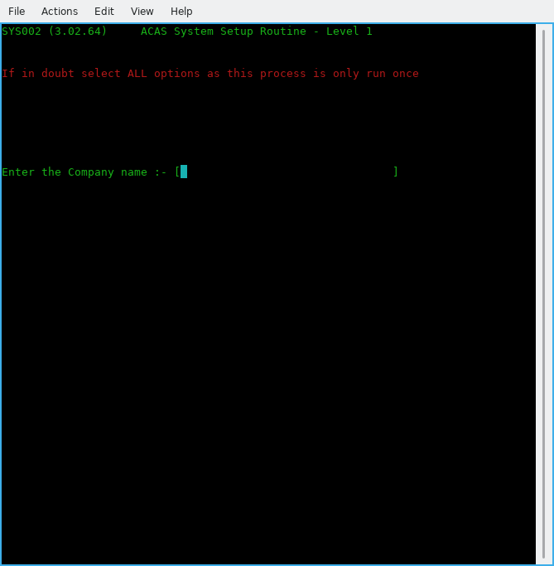

Figure 6.1 - Business name entry

(0-01) Enter the Company Name

This is the name of the company for whom ACAS will process. If ACAS will be used on several client companies, this name clearly separates the data of different companies. Maximum length is 32 characters. After typing the name and hitting enter you will be asked to verify it is correct by entering Y or y. If not, enter N or n and you can re-enter the information.

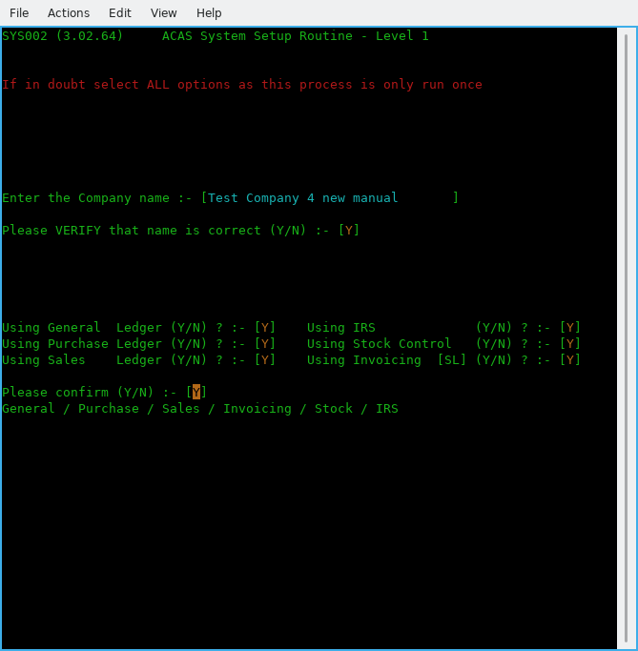

Figure 6.2 - The various ACAS systems to be used

The next series of questions requests what ACAS functions will be used, see figure 6.2.

(0-02) Using subsystem xxxxxx

Here enter a Y or N against each entry in turn depending on your requirements. If in any doubt turn them all on unless you know that you will not be using them e..g., Stock Control, Order Entry if you are a services only company and do not hold stock. Having responded to all questions you will be asked to confirm selection and at the same time a display below the question will show what has been selected. If you are happy, enter Y and return else enter N and you can re-enter the answers.
[ You can not re-do this group of questions so always specify all sub systems and make sure that the business name is also correct before moving on. ]

The parameter requests and their defaults are shown and described individually in the remainder of this chapter. The number in parentheses is not displayed by the system but is printed in the manual for reference.

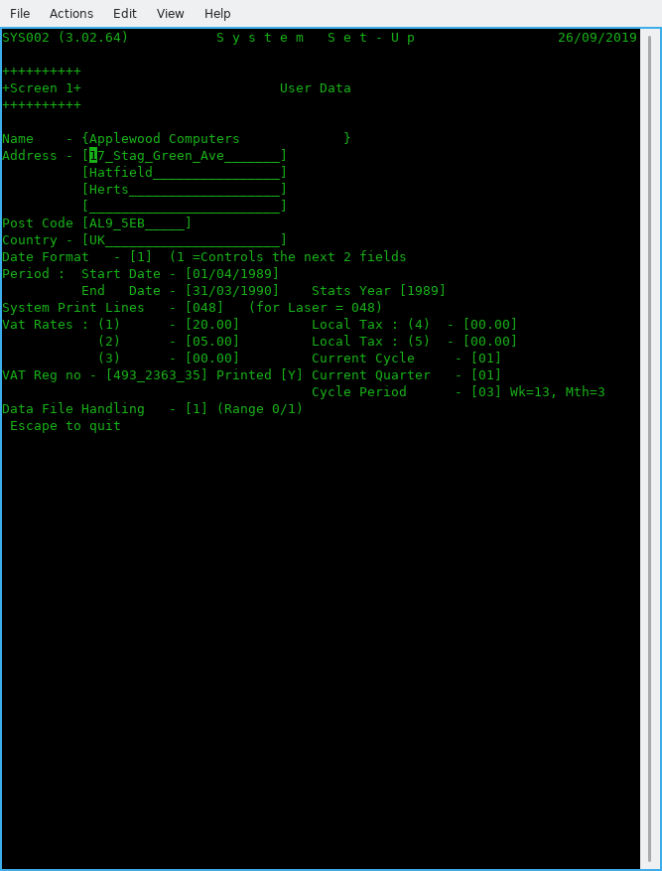

Figure 6.3 Screen 1 – User Data

(1-01) Company Address – 4 lines

Enter up to 4 lines of address (24 Characters each) excluding Postcode and country, that's next.

(1-02) Company Postcode or zipcode (12 characters).

Enter the postcode then the County.

(1-03) Date format.

Select the format used in your country.
Select 1 for the UK (dd/mm/ccyy),
2 for the USA (mm/dd/ccyy)
3 for international (ccyy/mm/dd)

(1-04) Start Date
(1-05) End Date

Enter the start and end dates for the current financial year in the format selected above (1-03)
you can use '/' or '.' to separate the day, month & year as it will be converted to '/' as needed.
For example in the UK they would be:
01/04/2012 and 31/03/2013

(1-06) System Print Lines.

For a laser and Inkjet set to 048 as a good starter and adjust if your reports are printing, too long or too short. For a matrix or line printer use 66.

(1-07) Vat Rates (1) (2) (3)

Enter the current Vat / tax rates with the more commonly used at the beginning. Using TAB to go to next field. This normally would be rate 1 – Standard, rate 2 – Reduced and rate 3 – any other such as zero.

(1-08) Local Tax

If needed set these similar to Vat Rates. (For the UK leave as zero). The O/S (open source) versions do not currently use these two rates but if needed issue a Feature Request.

(1-09) Current Cycle

Enter the cycle to be used, e.g., in the UK and at the start of the financial year using for month 1, week 1 enter 01.

(1-10) VAT Reg no

Enter your VAT or DST registration number then select Y if it is to be printed otherwise N for not.

(1-11) Current Quarter

Likewise in previous entry (1-09) e..g., in the UK at the start of the financial year enter 01.

(1-12) Cycle Period

Enter the relevant period e..g., 03 for Monthly, 06 fortnightly and 13 for weekly. The normal value here is 03 for monthly.

(1-13) Data File Handling

Set this to zero for normal Cobol files and for RDBMS (Database) processing set to :
1 for MySQL.
The following are not implemented and will be subject to user requests.
2 for Postgres, 3 for Oracle, 4 for DB/2 and 5 for MS SQL Server.

See later for setting the RDBMS entries in (3.01) onwards.

Pressing enter now will bring up a confirm message and if you need to change any of the settings , e..g., Date format, Cycle period, Cobol data files used etc, select N and re-do any in error.

If all is correct enter Y to go to screen 2.

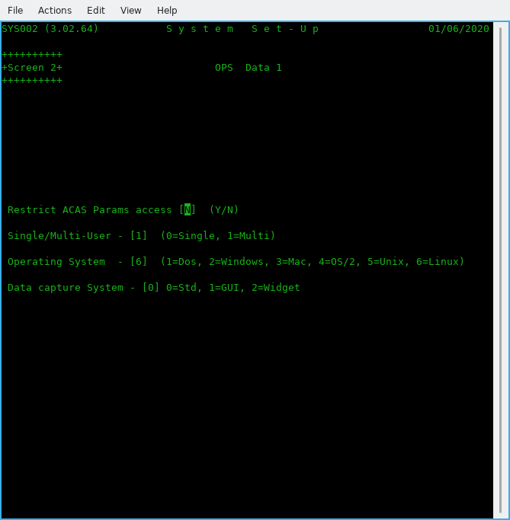

Figure 6.4 Screen 2 – OPS Data 1

(2.01) Restrict ACAS Param access [N]

Enter N (for No) or Y (for Yes). Normally leave as N.

(2-02) Single/Multi-User – [0]

Enter 0 = for Single or 1 for Multi-user systems. If more than one user will be using the ACAS system possibly at the same time select 1. Normally enter 1.

(2-03) Operating System - [0]

Enter the correct value for the OS (operating system), Make sure you select the correct value as ACAS will function differently depending on system in use. Most common is Linux or Windows. If in doubt ask your IT department.

(2-04) Data capture System - [0]

Enter zero for now but options are 0=Std, 1=GUI, 2=Widget. This entry is for future expansion.
After pressing the Return key, the system will ask to confirm your answers.

(2.05) A new box appears for all other than Dos, requesting the print spool names as set up e.g., in Cups when using Linux, Unix or OSX.

Type the name in exactly as set up in Cups, be careful regarding case e..g., upper and/or lower case – they are different.

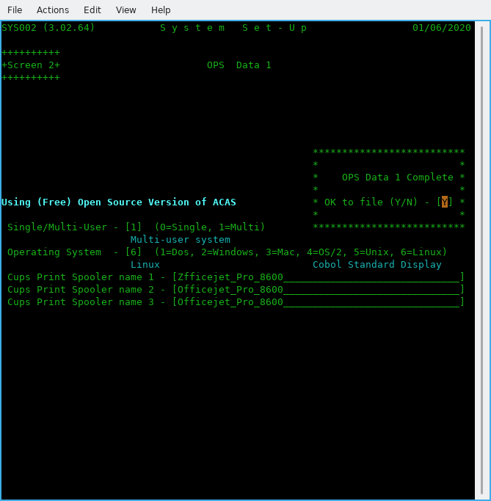

Figure 6.5 Screen 2– OPS Data 1 after data entry

If this is wrong you will not get any reports. A good test that this is correct is after you say Y to the print a hard copy of the parameters question at the end, it will produce a report. The typical error produced for this is: 'lpr: The printer or class does not exist' as shown at the command prompt having exited from ACAS.

If you selected RDBMS processing then screen 3 will now appear.

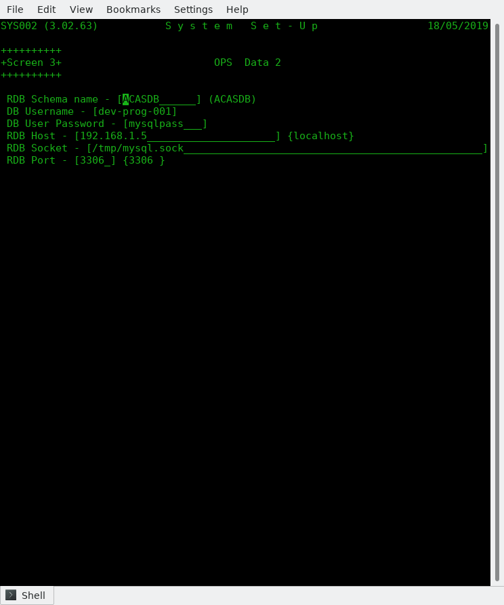

Figure 6.6 Screen 3 -- OPS RDBMS Data

Here you enter the various parameters for access to the data base.

(3.01) RDB Schema name -- Defaults to ACASDB.
(3.02) DB Username -- Give the user name as set up in the data base.
(3.03) DB User Password -- Like wise their password.
(3.04) RDB Host -- The IP address of the system running RDBMS. Default localhost (the same computer you are running ACAS on.
(3.05) RDB Socket -- As set up in MySQL configuration file normally - my.cnf.
(3.06) RDB Port -- As above and defaults to the normal value of 3306.

You are asked to confirm your entries and giving N will restart again on OPS data.

Note that you must have the RDBMS system installed, running and configured with the ACAS data base tables - see Chapter Installing the ACAS DB structures in MySQL page 9.

Failure to do this and answering Y to update the parameter file with your data will result in error when the ACAS system attempts to update the data base table SYSTEM-REC having already updated the parameter file which is always created.

Should you not be in a position to have the RDBMS running with the ACAS database loaded you should change the setting for (1.13 to 0 (zero) to keep file processing active at least for the moment. You can, having got the Database loaded etc go back into parameter set up via menu option Z and set (1.13) to 1.

If having entered the RDBMS data and set Y(es) to save the param data and gotten error messages saying ACAS cannot access the database, when the system returns back to the beginning of parameter data entry, you can do the same and set (1:13) to 0 and the RDB information will be saved but the system will use Cobol data files for all processing -- very useful during system testing etc but note that the parameter report will not show RDB data is set to file processing.

Screen 4 is now displayed and that covers G/L Data.

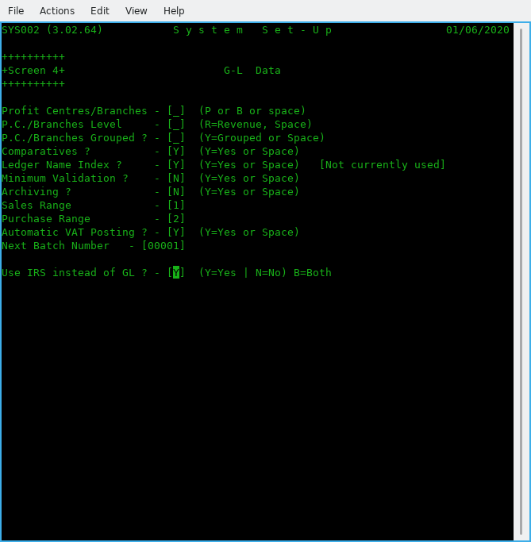

Figure 6.7 Screen 4 – G/L Data

This screen is only if you are going to use G/L instead of IRS in which case read the G/L manual for more information about the values but for the moment enter as per the figure 6.7 ie: enter a space for the three questions on P.C. (Profit centres) and 'Y' for comparatives and Ledger name index. Then enter space for the next 2 question on Minimum Validation and Archiving. Change as ** zero respectively for the next 2 questions on Sales and Purchase ledger ranges (which are preset to 1 and 2) followed by 'Y' for auto VAT posting, use 00001 for Next Batch number and finally Y if using IRS instead of G/L. **Note that if you need to set up the Sales and Purchase account entries in G-L you must leave these values initially as zero in order to create these accounts, otherwise the system will refuse to allow accounts starting with 1nnn and 2nnn to be created. After these have been set up you can change these two values to the correct leading numbers respectively however they do not seem to be currently used – Subject to system testing but for all system testing we currently only use IRS as that is used for company accounts.

Now pressing enter will again let you confirm the answers with the display showing what has been set..Use N if you spot any errors and re-enter the correct one answers and enter to go to the next screen. Use TAB or the arrow keys to move between entry boxes, this applies to most screens.

Now we finally get to parameters that relate to Sales Ledger on Screen 5

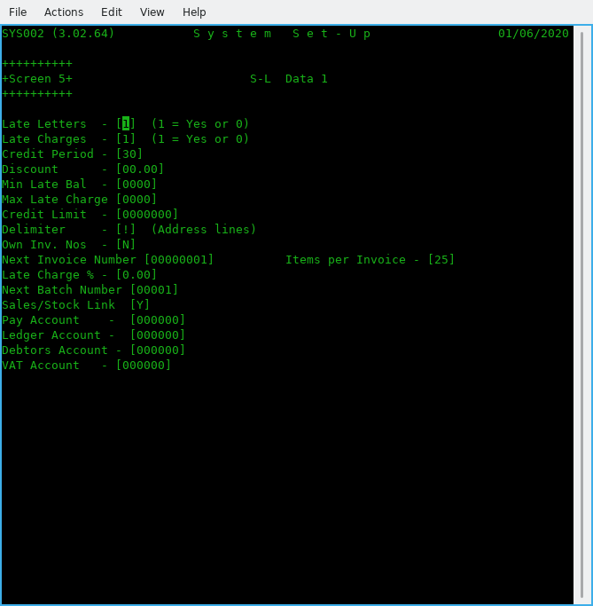

Figure 6.8 Screen 5 -- S/L Data 1

(5-01) Late Letters [1]

This request determines whether Late payment reminders (dunning) letters are used.
If yes set to 1, the late letter program may be used to write reminder letters to overdue customers.

(5-02) Late Charges

This request determines whether or not late charges are used throughout the system. If yes (1), the payments apply program will generate charges on overdue balances.

(5-03) Credit Period

This is the normal number of days to give for credit. You have the option of changing this for individual customers.

(5-04) Discount

Default discount offered to customers and again can be change for individual accounts.

(5-05) Min Late Bal

The Minimum Late Balance is the value below which late charges will not be applied.

(5-06) Max Late Charge

The highest amount that will be charged for late payments.

(5-07 Credit Limit

During Customer Entry this is the amount that will be placed in each customer's record to show his or her credit limit in the absence of other instructions and you can over ride this value. It must be an integer from zero to 9,999,999. Balances over the credit limit are acceptable, but these clients will be flagged on reports and on Invoice entry.

(5-08) Delimiter

This is the character that delimits address lines. It is recommended to be set as '!'. unless you get the same character within addresses in which case select another that is not used and one to consider is ‘|’. Despite what was acceptable for earlier version of ACAS you cannot use the slash symbols e.g., ‘\’ or ‘/’ as these will interfere with running using rdbms and are now not allowed.

(5-09) Own Inv. Nos

Will the users be entering your own invoice numbers?
Set to N if you want the system to handle it. If so, the system will also reallocate deleted invoice numbers so you do not end up with missing numbers for audit purposes.

(5-10) Next Invoice Number

Leave this set to 1 for new system set ups -- this will be incremented by 1 for every invoice created in the system so if it is a higher number normally you would leave it as is.

(5.11) Items per Invoice

Defaults to 25 but change it for the number of item lines to be printed in one invoice page.

(5-12) Late Charge %

This is the percentage of the outstanding amount that will be used as the late charge.
This number may contain 1 digit to the left and up to 2 digits to the right of the decimal. For example, the default of 1.5 is one and one half percent of the overdue balance. Lowest values are 0.00 and highest 9.99. This charge applies per cycle e..g., monthly.

(5-13) Next Batch Number
Normally set this to 1 if S/L not yet processed any invoices otherwise shows current next batch no.

(5-14) Sales/Stock Link

Set to Y if using Stock Control and you want it linked for invoice production. Else set to N.

(5-15) BO Link

Set to Y if you wish to use the Back Order process functions as and when needed.

(5-16) BO Default

Set to N or Y for all Customer records as the default value. Defaults to N - customer can not have any BO processing for their account. This applies to only newly created accounts and any existing ones will continue with the default set to N. You can of course change these one by one to Y as needed but an option has being made to Customer amend to allow a one pass change to all records or records where the account number has a specific prefix or a specific account.

(5-17) Pay Account

This is the number of the account to which all payments/cash receipt transactions will be debited.

(5-18) Ledger Account

This is the number of the account to which all sales transactions will be credited.

(4-19) Debtors Account

This is the number of the account to which all sales transactions will be debited and all cash receipts transactions credited

Note: Assuming IRS or G/L has been set up with a CoA (Chart of Accounts) you can enter the relevant accounts. If not set up or you will not be using either system then leave as zero.

(4.20) VAT Account

Enter the account that you have or will set up to hold VAT for Sales inputs.

After pressing enter for this last parameter you will be asked to confirm the S/L settings with the screen being updated to show your settings. Entering Y will move on to the next S/L screen.
Only four entries here all with a Y or N as valid data
Should the company name and address be printed for Invoices, Statements, Late Letters and delivery notes.

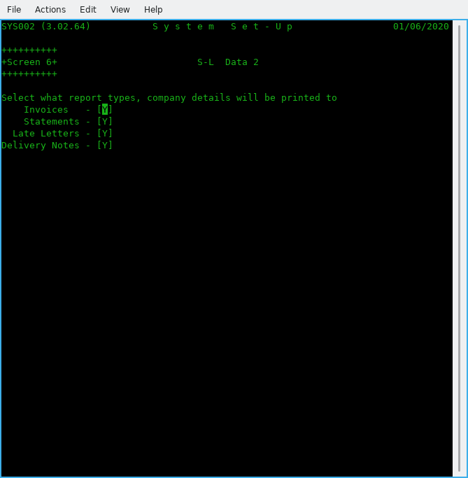

Figure 6.9 Screen 6 -- S/L Data 2

The next screen, 7 is for P/L data

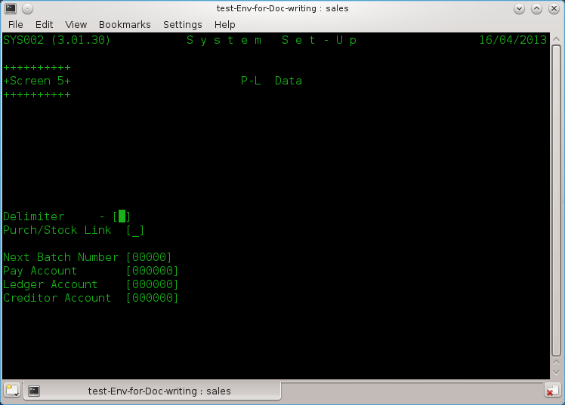

Figure 6.10 Screen 7 – P/L Data

Purchase Ledger parameter data is a small but similar element of the S/L data. So now you know what is what regarding S/L, P/L will be a 'piece of cake' as there is a lot less fields.

(5-01) Delimiter

This is the character that delimits address lines. It is recommended to be set as '!'. unless you get the same character within addresses in which case select another that is not used and one to consider is ‘|’. You should be using the same one for both Sales and Purchase Ledgers to avoid confusion when entering data. Despite what was acceptable for earlier version of ACAS, you cannot use the slash symbols, e.g., ‘\’ or ‘/’ as these will interfere with running using RDBMS and are now, not allowed.

(5-02) Purch/Stock Link

Set to Y if using Stock Control and you want it linked for purchase orders. Else set to N.

(5.03) Next Folio Number

Normally set to 1.

(5-04) Next Batch Number

Normally set this to 1 if P/L not yet used otherwise shows current next batch no.

(5-05) Pay Account

This is the number of the account to which all payment transactions will be debited.

(5-06) Ledger Account

This is the number of the account to which all purchase transactions will be credited.

(5-07) Creditors Account

This is the number of the account to which all purchase transactions will be debited and all cash receipts transactions credited.

Note: Assuming IRS or G/L has been set up with a CoA (Chart of Accounts) you can enter the relevant account numbers. If not set up, or you will not be using either system then leave as zero. Also see comments earlier regarding using both IRS and G-L.
Warning: The system will not check that these accounts have been set up, the same applies to S/L so any postings could just disappear.

After pressing enter for this last parameter you will be asked to confirm the P/L settings with the screen being updated to show your settings. Entering Y will move on to the next screen.

We now move on to the secondary systems.
See the ACAS - Stock Control System manual for more information on these, if needed.

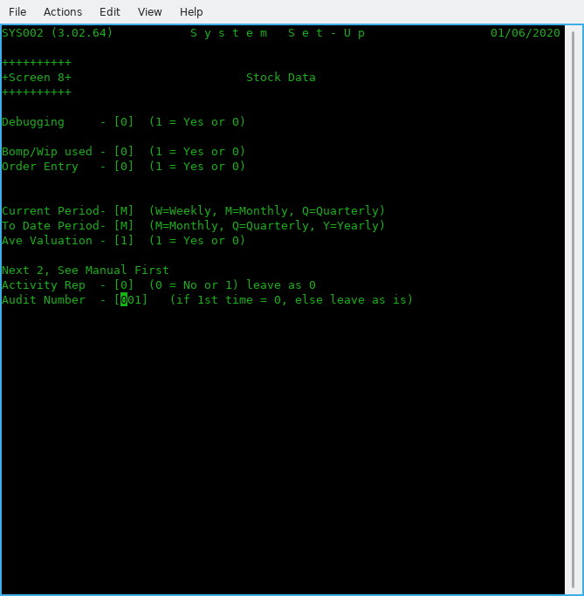

Figure 6.11 Screen 8 - Stock Control

(6-01) Debugging
Unless requested by technical support leave this as 0.

(6-02) Bomp/Wip used

Set to 1 if you need Bill of Materials Explosion / Work In Progress functionality. Otherwise 0.
See the Stock Control manual for more details for this and the other parameters in this section.

(6-03) Order Entry

Set to 1 if using the Order Entry system. [Not for the O/S version, so is set to 0.]

(6-04) Current Period

Declare what the reporting period is: M = Monthly (recommended), W = Weekly & Q = Quarterly.

(6-05) To Date Period

Declare what the 'To Date' Period is;. M = Monthly, Q = Quarterly & Y = Yearly (recommended).

(6-06) Ave Valuation

Set Average valuations on for current stock, otherwise you will need to maintain stock valuations yourself – a tiresome and possibly long winded and error prone process.

(6-07) Activity Rep

Set to 1 for recommended setting and this produces reports for all stock movements (Audit).

(6-8) Audit Number

Start number. Set it to 0 unless system has been running then leave it unchanged.

On pressing return will ask you to confirm settings having displayed summary details.

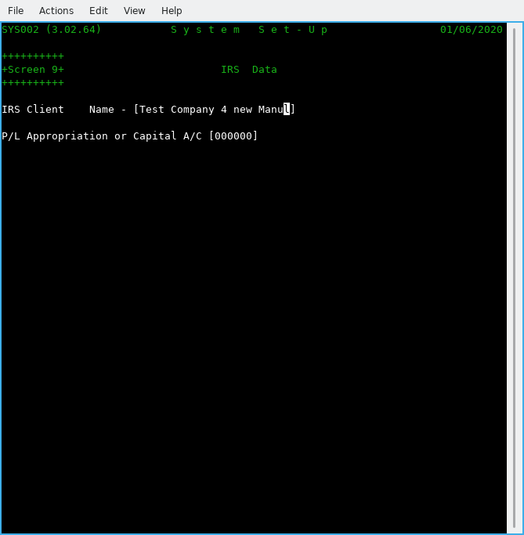

Figure 6.12 Screen 9 -- IRS Data.

Specific data for IRS as all other required data is taken from the previous screens.

(7-01) IRS Client Name

Enter the name of the client for the IRS system or use the name of the business / company as entered in 0-01 and this would be the normal entry unless you will use IRS for processing more than one company accounts.

(7-02) P/L Appropriation or Capital A/C

Enter here the IRS or GL account number for this account which if using the supplied sample IRS accounts would be 000195 or more likely 000295. This is the account that will be used when running EOY (End of Year) processing at the end of the IRS menu option 7 ‘Accounts Production’ where it asks if you wish to run end of year. Here the system having cleared the posting file and reset all of the CoA (Account ledgers) will post OTB (Opening Trial Balance) entries for all the brought forwards accounts. The account entered is not checked that it is present. See the IRS manual for more information.

Now to print out the details of the parameter files for your records, so select Y.
Warning: This does not print out all the parameter file settings.

Note that new parameters can be added to the data entry screens discussed in this chapter at any point during testing and upgrades that might not be detailed see the README or Update notes regarding any such changes.

System Note:
As at the date of updating this document (see inside front cover) GL (General Ledger) does not function the same way at all as IRS, but just clears down the posting file at the end of each reporting period. This is not the way it should work and two additional programs will be added to do this correctly that will cover Final Accounts Setup and Reporting, and this after completion of testing v3.02 of IRS, SL, PL and Stock Control.

One additional program for sundry processing to support the processing of garbage collection (bad data recovery) will also need adding subject to Final Accounts processing. It might be necessary to add or change other processes that are missing or buggy in GL during unit and system testing.

GL has not had any testing since migration over to GnuCOBOL due to time constraints and the fact that IRS does all General Ledger processing but without the extra complexity of handling separate branch or multiple Profit Centre processing or SCFP (Statement of Changes in Financial Position).
It is not being anticipated to rebuild the later, as most business will require the use of a CA (Chartered Accountant) to utilise correctly and also requires updates subject to changes in government requirements for taxation which occurs each year around budget time.

Very similar to Payroll in that both require continuous chargeable support through a yearly maintenance contract.

Therefore these options will not be provided for the open source version of ACAS.

Sample ACAS Parameter File Set up Report
SYS002 (3.02.64) S Y S T E M P A R A M E T E R S 2020/05/31 Page 1

User Parameters G/L Parameters
**************** ****************

Name Test Company for new Manual Using IRS instead of GL - Yes
Address Any old Road Neither P/C or Branches Selected
Any Town

AA1 2BB, UK Comparative Figures Required
Date Format Intl Format Alphabetic Ledger Index Selected
Period Start 2020/04/01 Statistics Year 2020 Full Validation During Data Entry
End 2021/03/31 Transactions Deleted at End of Cycle
VAT Rate 1/4. 20.00 / 0.00 VAT Reg: GB493123498 (P) Sales Range most Significant Digit is - 1
Rate 2/5. 5.00 / 0.00 Purchase Range Most Signif. Digit is - 2
Rate 3. 0.00 Auto VAT Posting Selected
Current Quarter 1 Cycles per Quarter - 3
Current Cycle 1 Next Batch Number - 1
Print Lines 48

ACAS Parameters P/L Parameters
**************** ****************

Environment Multi User Address Delimiter !
Op. System Linux Next Batch Number 00000
System version Using (Free) Open Source Version of ACAS Next Folio Number 00000001
Cobol Data Files Used Pay Account 000000
Path to BIN /home/vince/bin Ledger Account 000000
Path to Ledgers /home/vince/ACAS/Building-Manual Creditor Account 000000
Prt Spool Name 1 Zfficejet_Pro_8600 Stock Control Link Yes
Prt Spool Name 2 Officejet_Pro_8600
Prt Spool Name 3 Officejet_Pro_8600

Inv. Parameters S/L Parameters
**************** ****************

Next Inv. Number 00000001 Computer Generated Invoice Numbers Selected
Dunning Letters Selected
Late Charges Selected
Inv. Data Level 2 Credit Period 30 Days
Standard Credit Limit 500
VAT Account 000000 Standard Discount is 0.00%
Print VAT Nunber Yes Min. Late Balance 0
Prt Inv Max Itms 25 Max. Late Charge 0
Late Charge Rate 0.00%
Address Delimiter !
Proforma Retent. 0 Next Batch Number 00001
Company Heads Print on Delivery notes: Y Stock Control Link Yes
Company Heads Print on Invoices : Y Pay Account 000000
Company Heads Print on Statements : Y Ledger Account 000000
Company Heads Print on Late Letters : Y Debtors Account 000000
SYS002 (3.02.64) S Y S T E M P A R A M E T E R S 2020/05/31 Page 2

Stock Parameters IRS Parameters
**************** ****************

Debug Mode No IRS Client Test Company for new Man
Manufacturing No
Audit in Use Yes
Movement Audits Yes
Current Period Monthly
To Date Period Monthly
Stock Averaging Yes
Current Audit No 00000001

Payroll Parameters RDMBS Parameters
****************** ****************

Payroll in Use No

System Parameters
****************

PL Approp A/C 000000

End of System Parameter Report
==============================

Command Key Summary

Note that these can be slightly different depending on the Cobol compiler you use, the operating system and/or your system settings.

Escape: Ends the current function or program other than menus.

Return: Enters data and advances to next request, accepts default value, moves cursor forward screen fields.

^ (UP ARROW): Moves cursor back one field.
Page Up: As above.

(Down ARROW): Moves cursor forward one field.
Page Down: As above.

Tab: Moves cursor right to next field.

Back Tab: Moves cursor left to previous field.

F1 to F10: Where used, see specific program or function documentation.

Manual errors or omissions

No manual, much like software is ever bug free, so if you find elements missing or incorrect please report all via the bug reporting tool (Tracker) at the ACAS website on sourceforge.

Remember to specify the manual title and version when doing so, You can also use an email to the address on inside front cover with the subject of Bug: manual or Software etc.

Thank you

Vincent.

